Steps to Create Application load Balancer.

🡪 Create two EC2 Instances with same availability zones (us-east-1a) name like webserver1 and webserver2

🡪 Create two more EC2 Instances with same availability zones (us-east-1b) name like webserver3 and webserver4

🡪 In all the above EC2 instances install ‘httpd’ package and start the service

🡪 In webserver1, create a page ‘index.html’ with the content of “welcome to main page of webserver1” and create one more page ‘picture.html’ with the content of “welcome to Picture 1”

Path is /var/www/html

🡪In webserver2, create a page ‘index.html’ with the content of “welcome to main page of webserver2” and create one more page ‘picture.html’ with the content of “welcome to Picture 2”

Path is /var/www/html

🡪 In webserver3, create a page ‘index.html’ with the content of “welcome to main page of webserver3” and create one more page ‘video.html’ with the content of “welcome to video 3”

Path is /var/www/html

🡪 In webserver4, create a page ‘index.html’ with the content of “welcome to main page of webserver4” and create one more page ‘vedeo.html’ with the content of “welcome to video 4”

Path is /var/www/html

Create two ‘Target Groups’

1)picture

2)video

🡪In ‘picture’ target group add webserver1 and webserver2 Instances

🡪In ‘video’ target group add webserver3 and webserver4 instances

Now create a Load balancer of type “Application Load Balancer” and name it as “TestAppLB”

🡪While configuring this ‘TestAppLB’ load balancer select the option ‘existing target group’ and select the target group ‘picture’

🡪Save the application load balancer finally.

🡪If we observe the target groups ‘picture’ and ‘video’, ‘picture’ target group will have the load balancer and ‘video’ is not.

🡪In ‘TestAppLB’ got to ‘Listeners’ we will have the option ‘view/edit rules’.

🡪Go to ‘view/edit rules’ add the content by ‘insert rule’, path as \*picture\* and forward to ‘picture’ group and another content by ‘insert rule’, path as \*video\* and forward to ‘video’ group

🡪In ‘TestAppLB’ we have DNS as url, copy that url and test it in browser, we will see the default index.html content from webserver1. If we continuously refresh the page it wi display the content of webserver2.

🡪If we add ‘picture.html’ to the url will display the content of webserver1 picture.html page.

🡪test the url with ‘video.html’ also

---Means if the content related to ‘picture’ will share to the servers webserver1 and webserver2, and the content which is related to ‘video’ would be routed to webserver3 and webserver4.----

Creating 4 EC2 Instances

2 for us-east-1a (webserver1, webserver2) and 2 for us-east-1b (webserver3, webserver4)

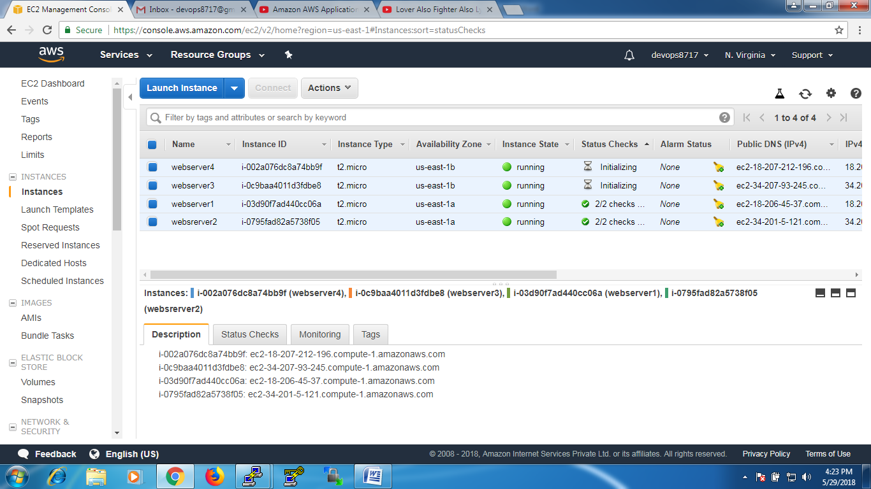

Connect webserver1 and install ‘httpd’ package and then create 2 files at /var/www/html

1. Index.html (content is “Welcome to main page of webserver1”)
2. picture.html (content is “ picture page from webserver1”)

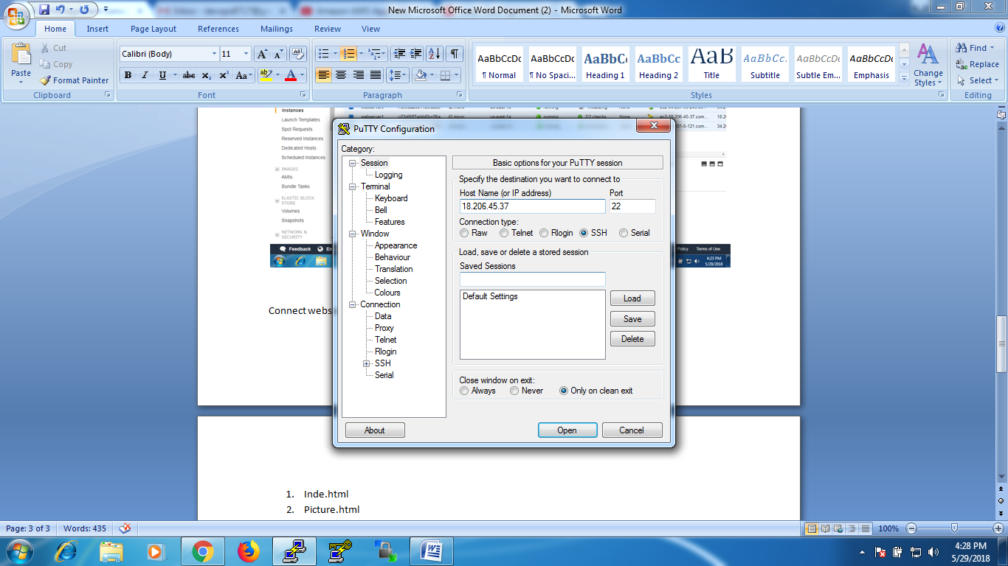

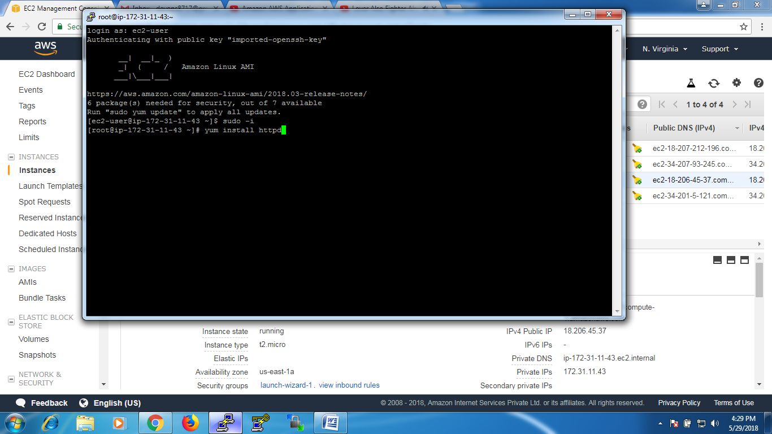

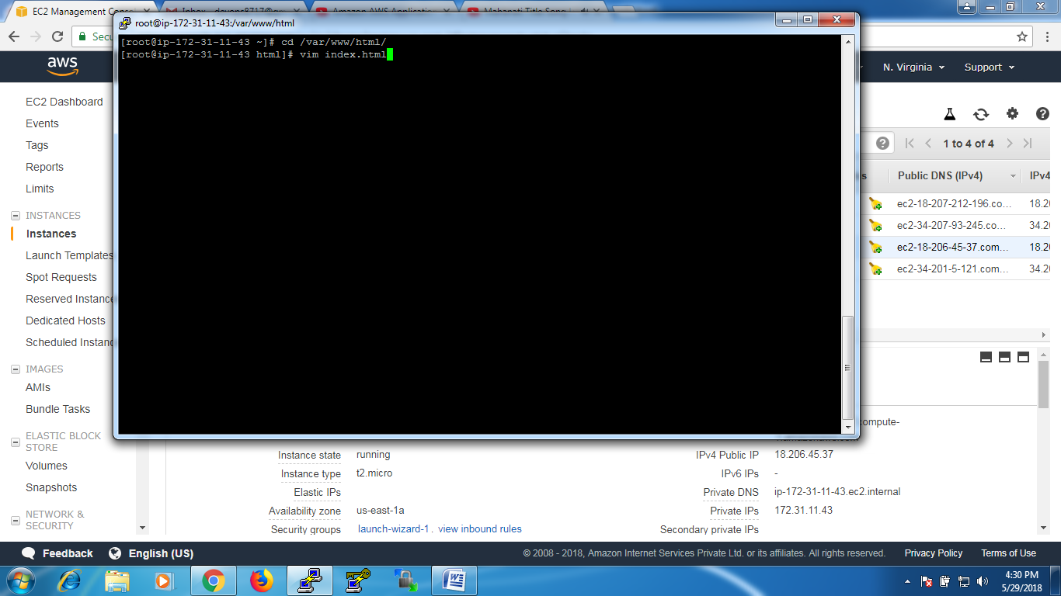

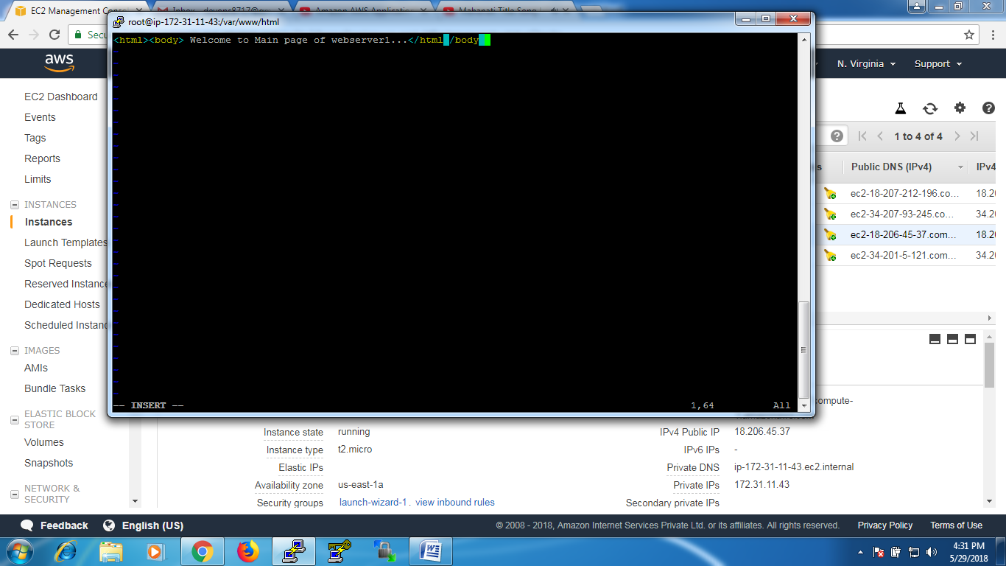 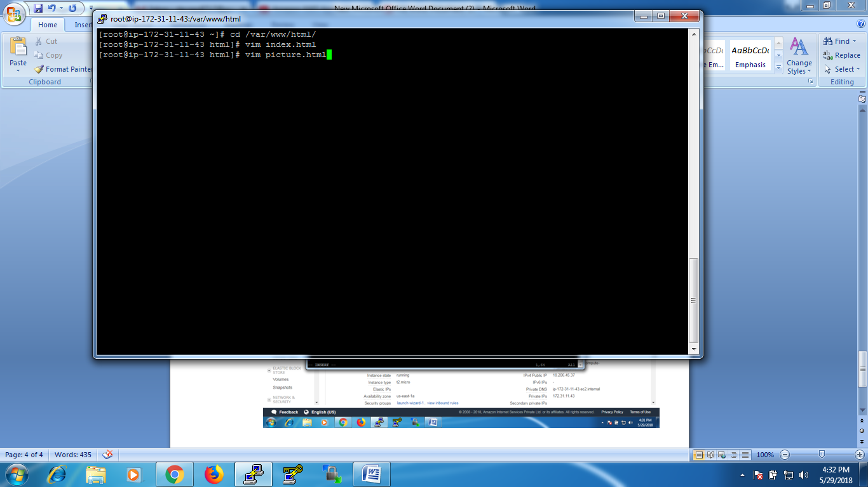



Connect webserver2 and install ‘httpd’ package and then create 2 files at /var/www/html

1. Index.html (content is “Welcome to main page of webserver2”)
2. picture.html (content is “ picture page from webserver2”)

Connect webserver3 and install ‘httpd’ package and then create 2 files at /var/www/html

1. Index.html (content is “Welcome to main page of webserver3”)
2. video.html (content is “ video page from webserver3”)

Connect webserver4 and install ‘httpd’ package and then create 2 files at /var/www/html

1. Index.html (content is “Welcome to main page of webserver4”)
2. video.html (content is “ video page from webserver4”)

Test every server is working fine or not with IP Addresses and with .html pages

Webserver1

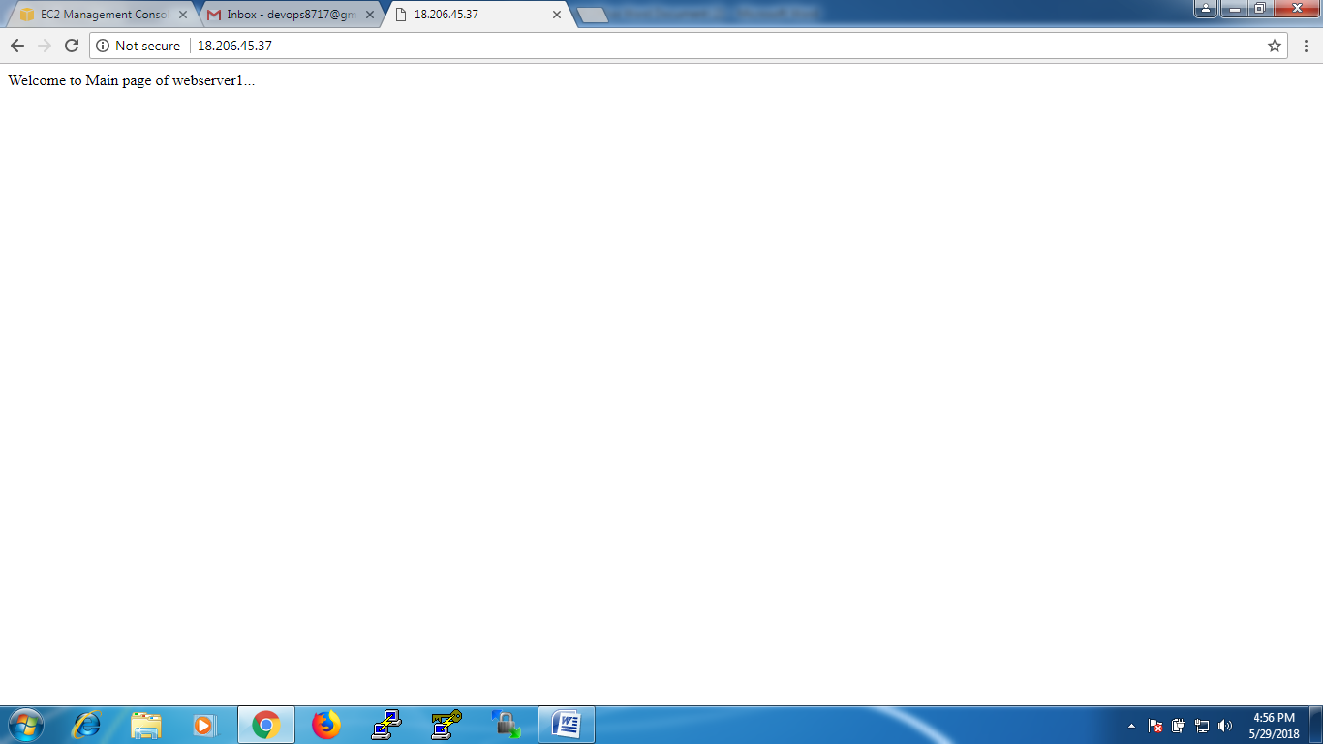

Webserver1 with picture.html page

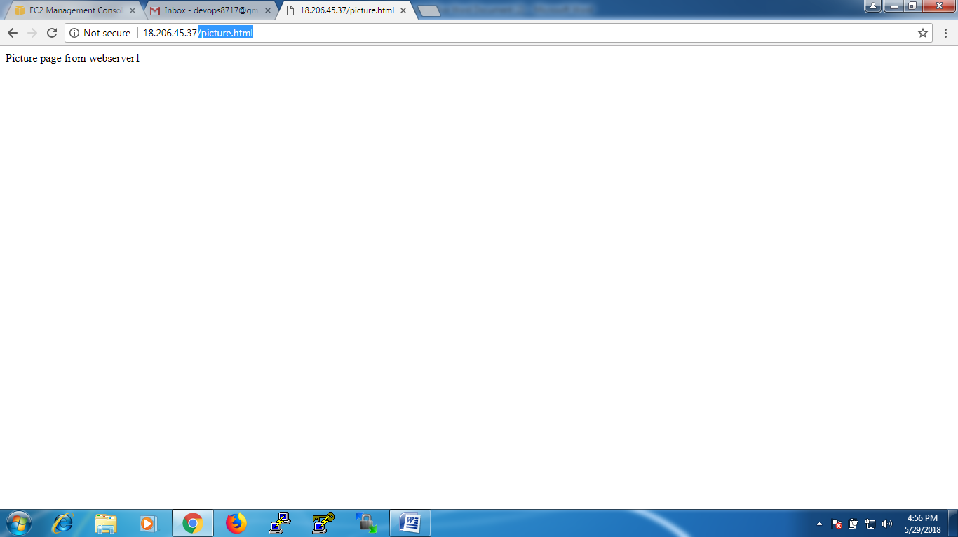

Webserver2

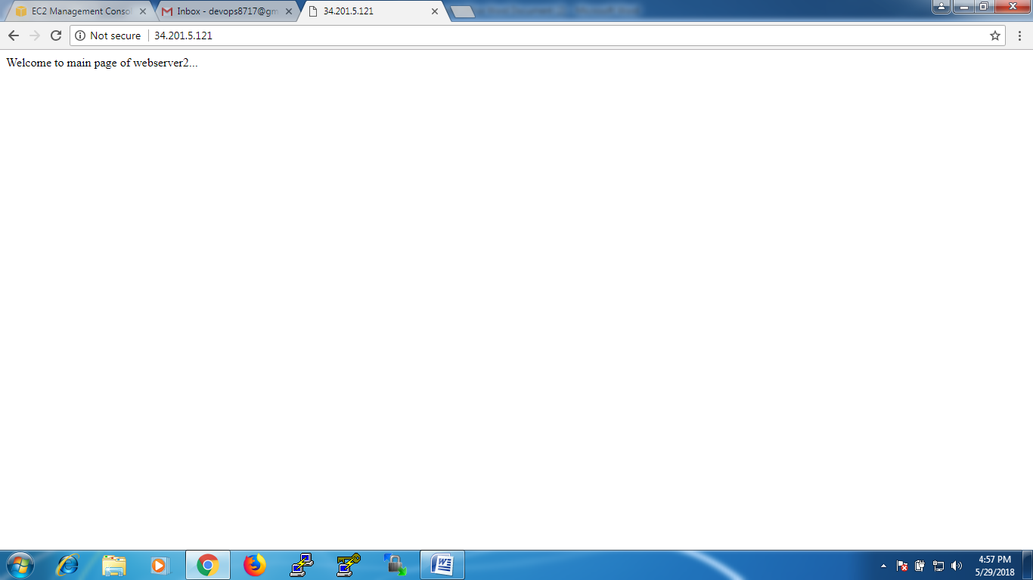

Webserver2 with picture.html page

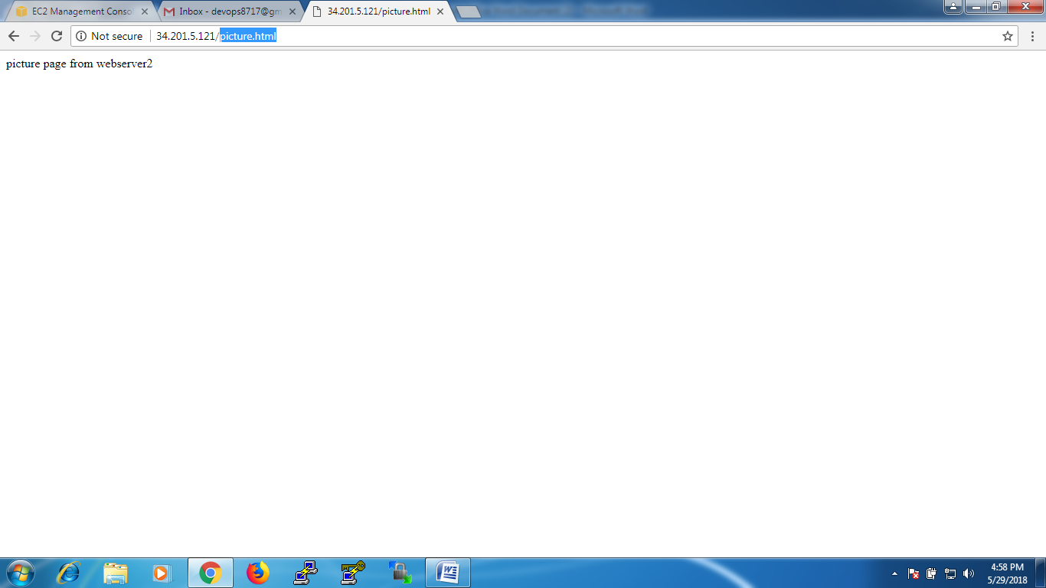

Webserver 3

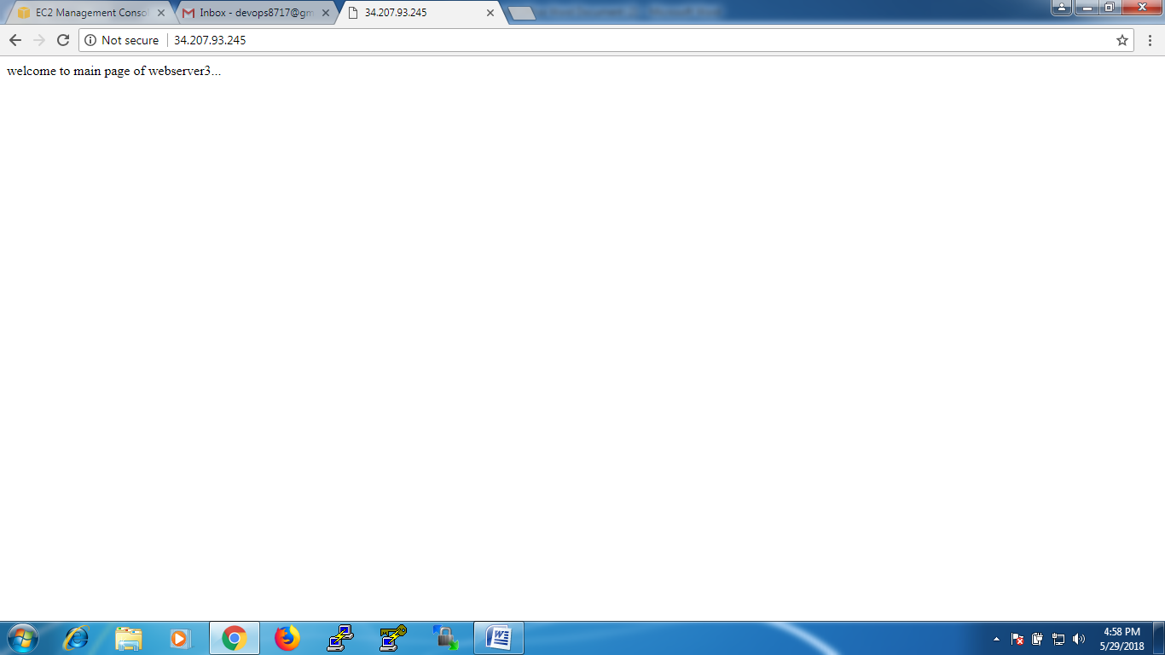

Webserver3 with video.html page

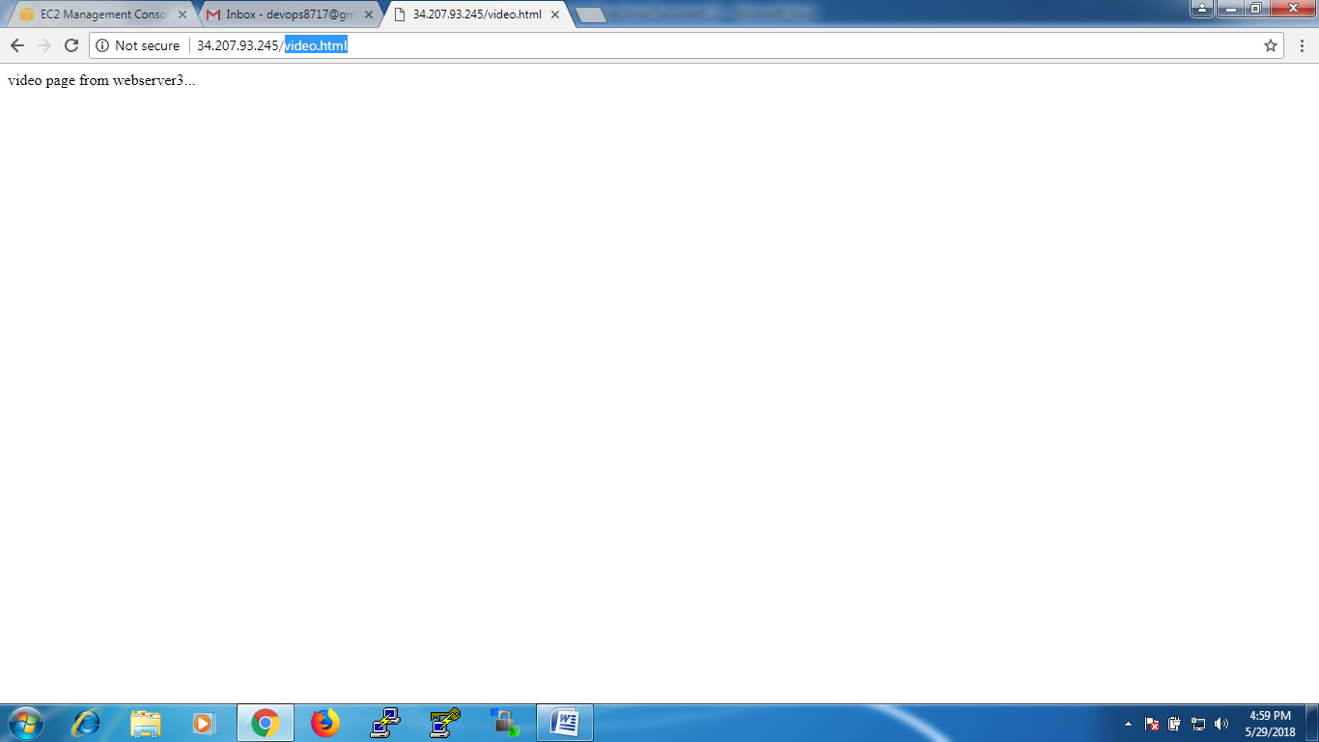

Webserver4

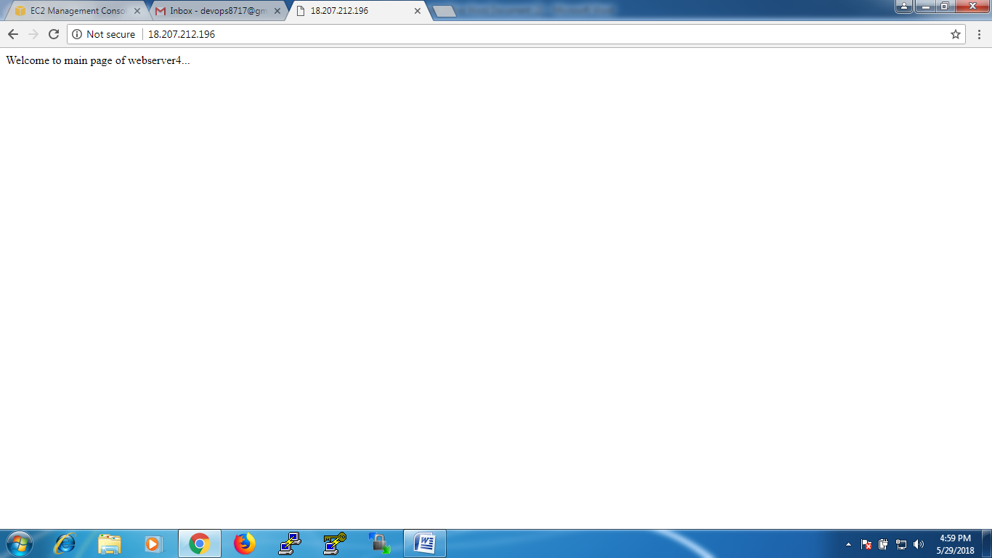

Webserver4 with video.html page

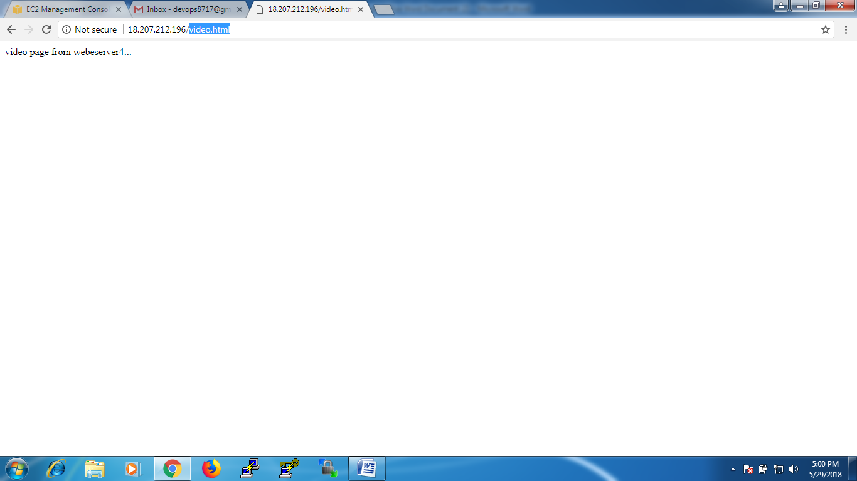

Now create a ‘Target Groups’

EC2 Dashboard -- Load Balancing – Target Groups –Create Target Group

Give the name ‘piture’ and give the path ‘/var/www/html/index.html’

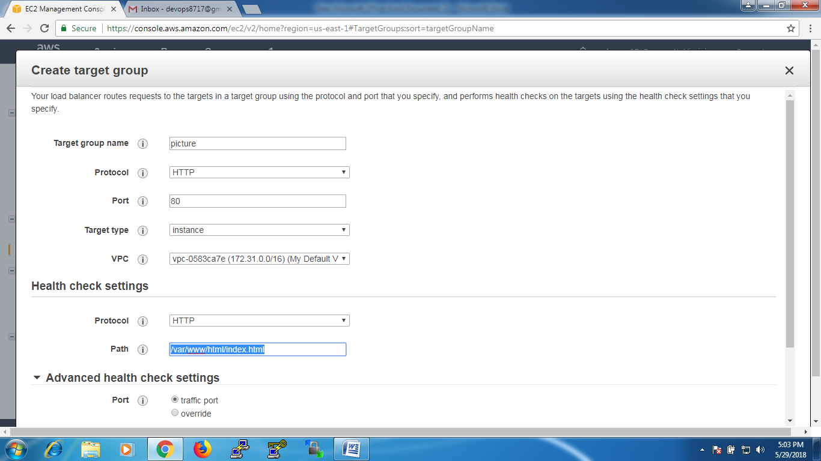

In Advanced Health check set the default thing and click ok ‘create’

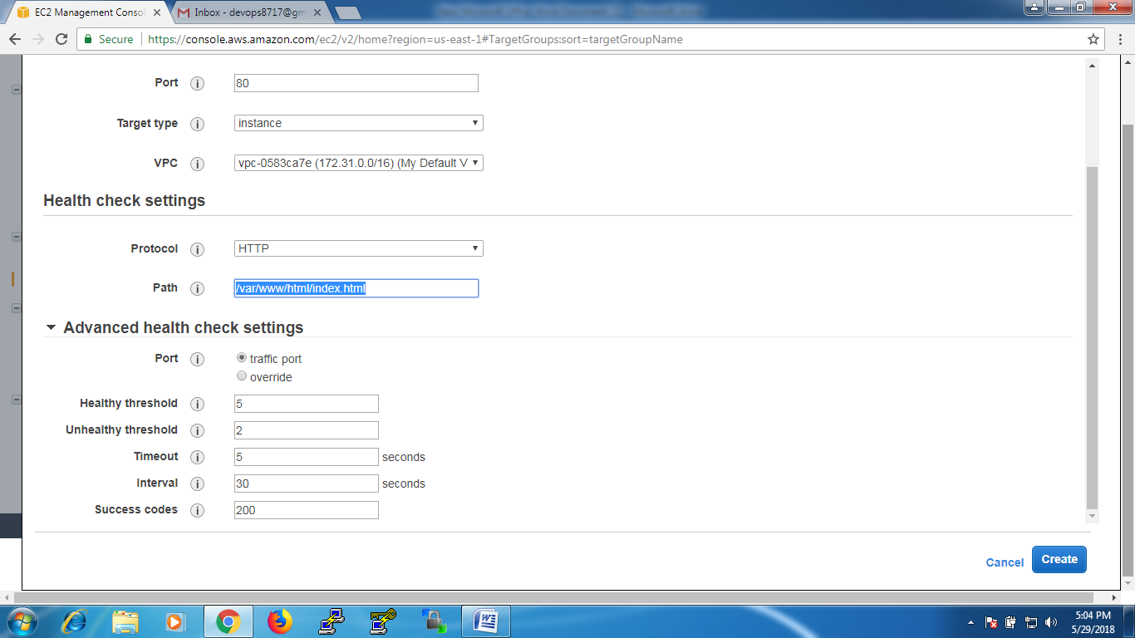

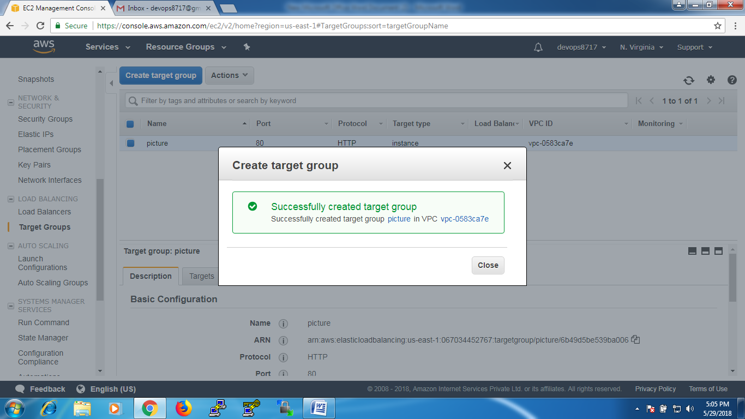

Create another Target Group ‘video’ and give the path /var/www/html/index.html

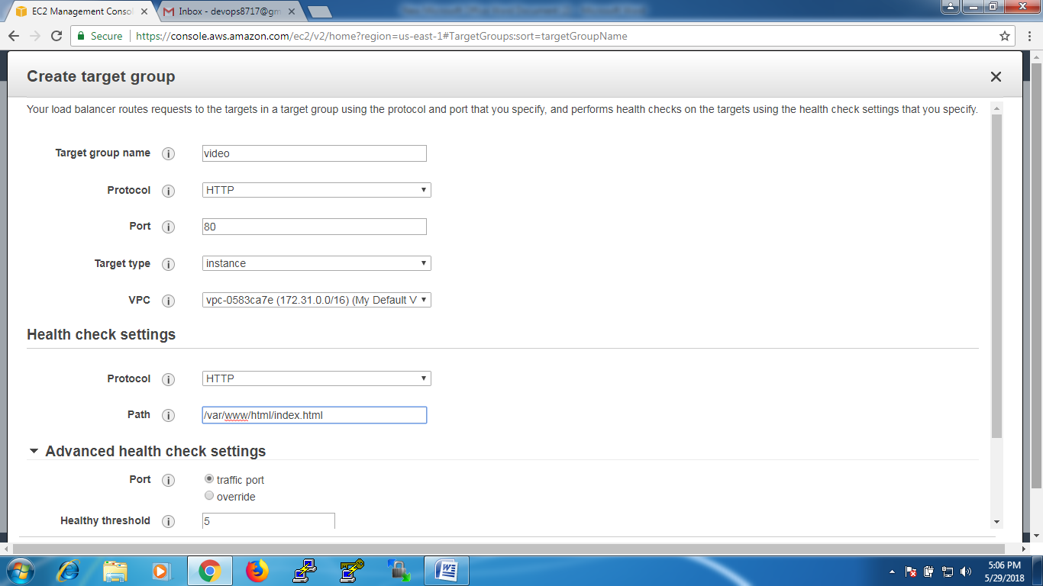

In Advanced Health check set the default things and click on ‘create’

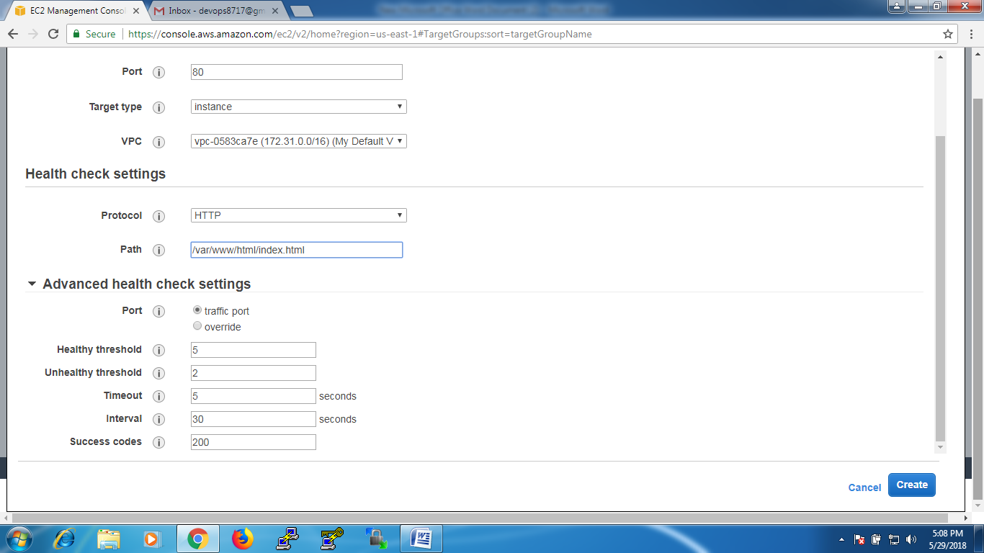

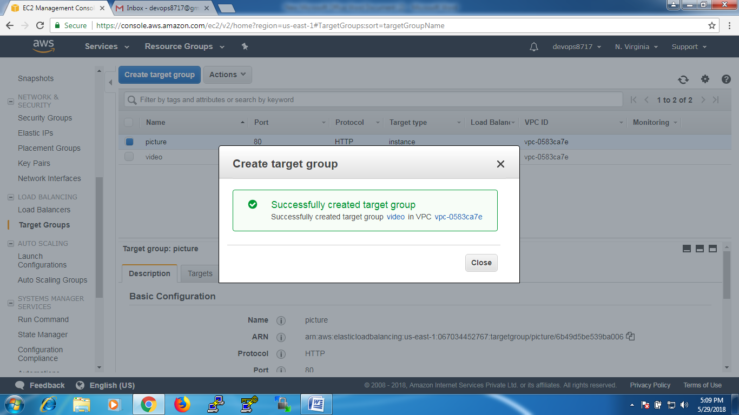

select ‘picture’ target group –select ‘targets’ --- click on ‘Edit’

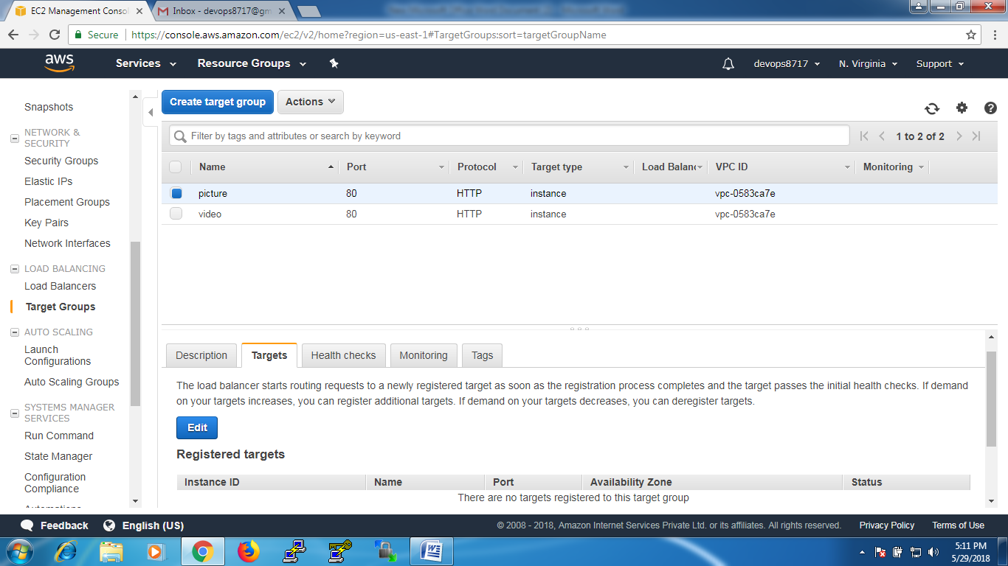

Add ‘us-east-1a’ instances to the target group ‘picture’ by clicking on ‘Add to registered’ --- click on ‘SAVE’

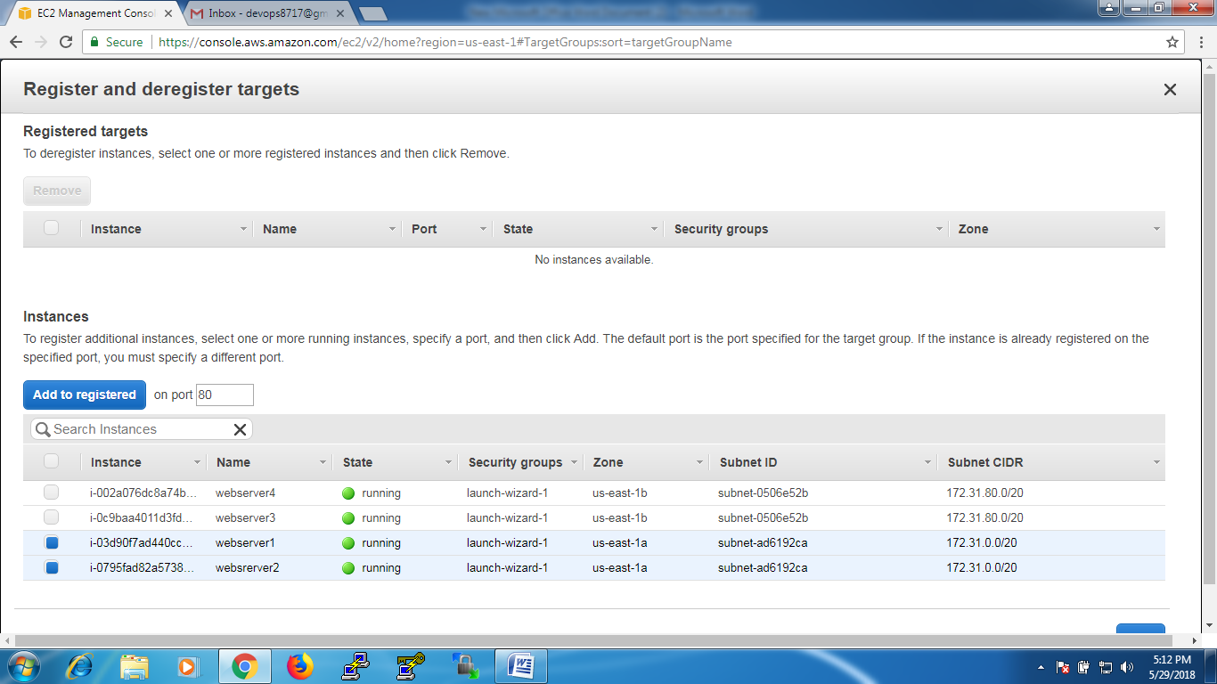

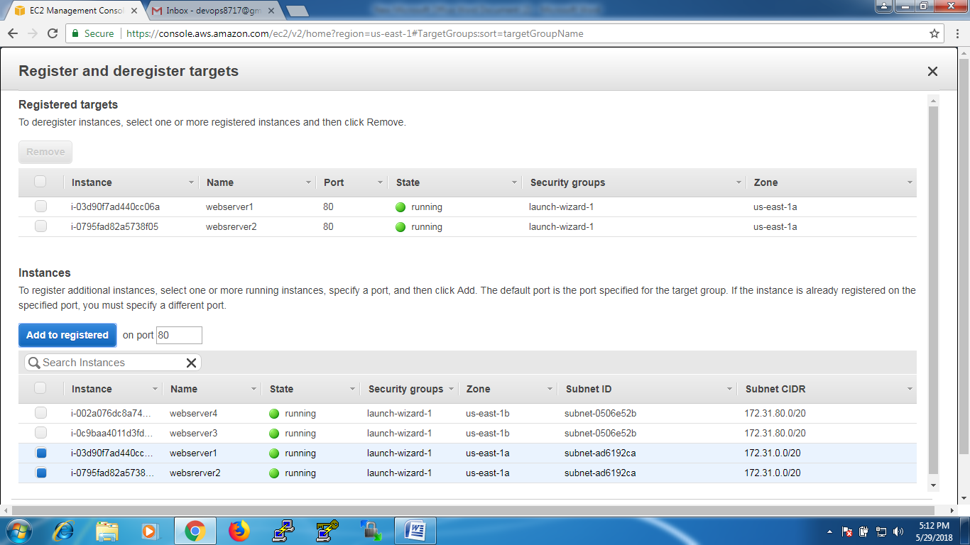

select ‘video’ target group –select ‘targets’ --- click on ‘Edit’

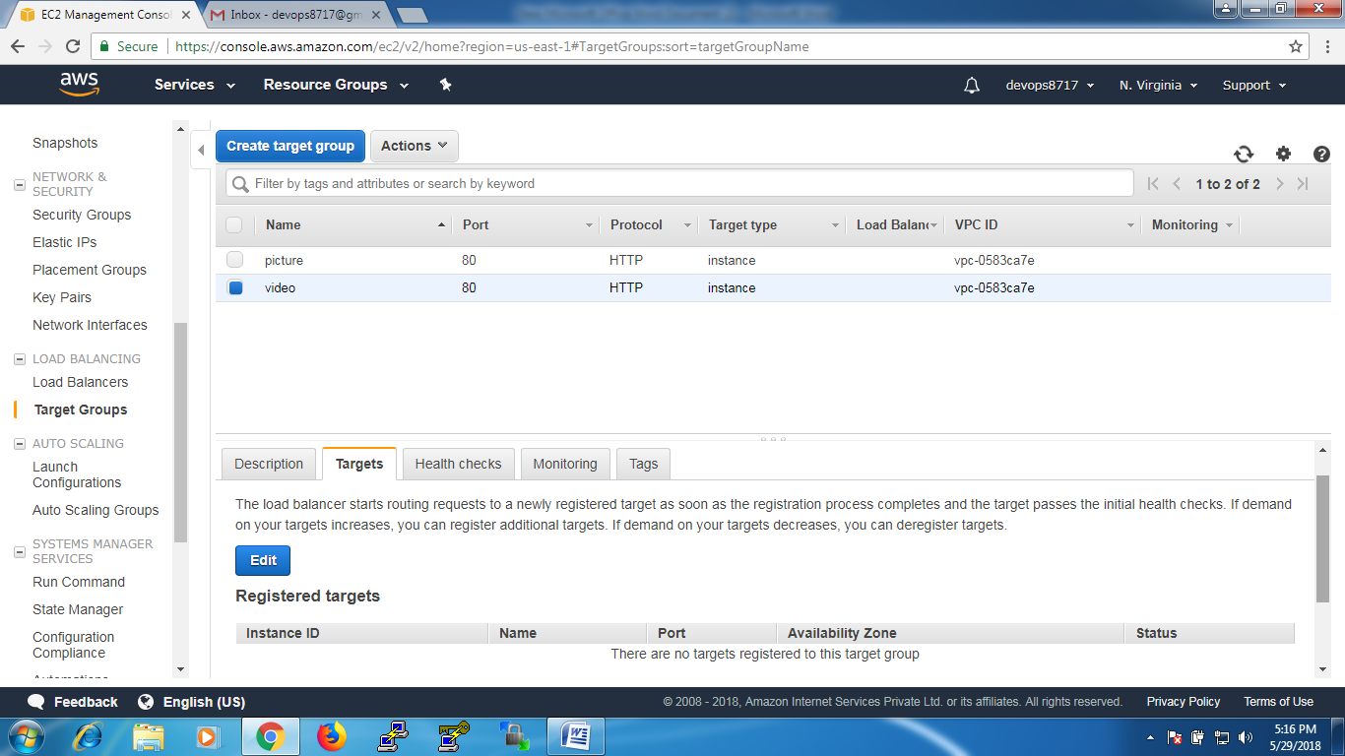

Add ‘us-east-1b’ instances to the target group ‘video’ by clicking on ‘Add to registered’ – click on ‘SAVE’

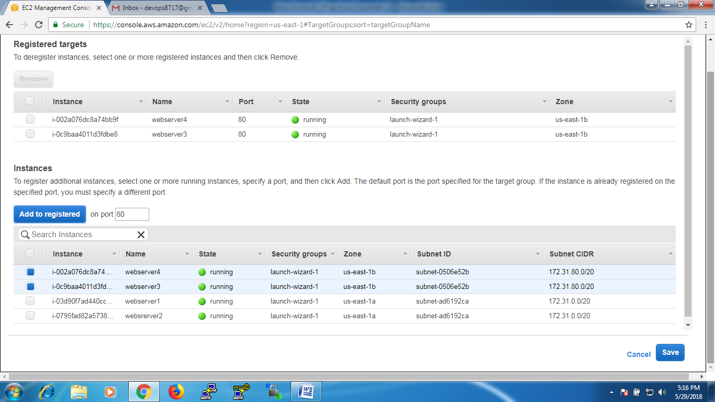

Now Configure Load Balancing i.e Application Load Balancing

EC2 Dashboard – Load Balancing –Application Load Balancing –Create

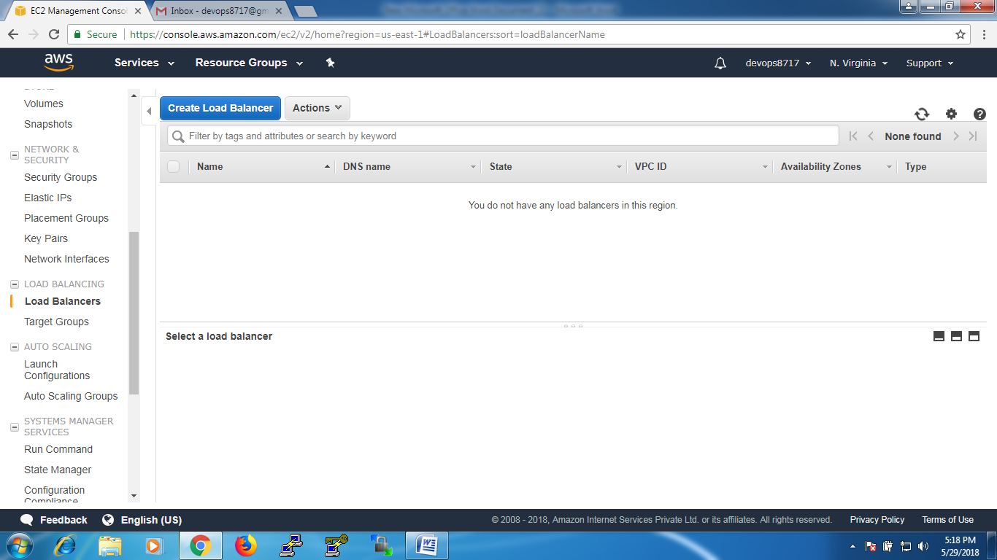

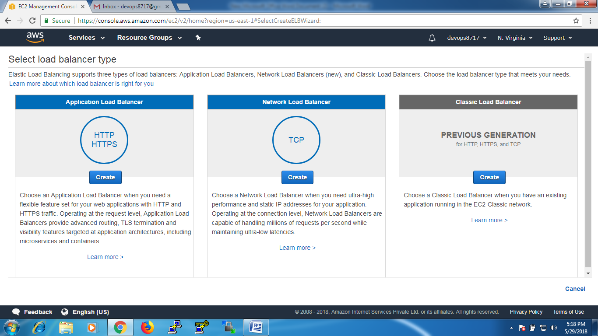

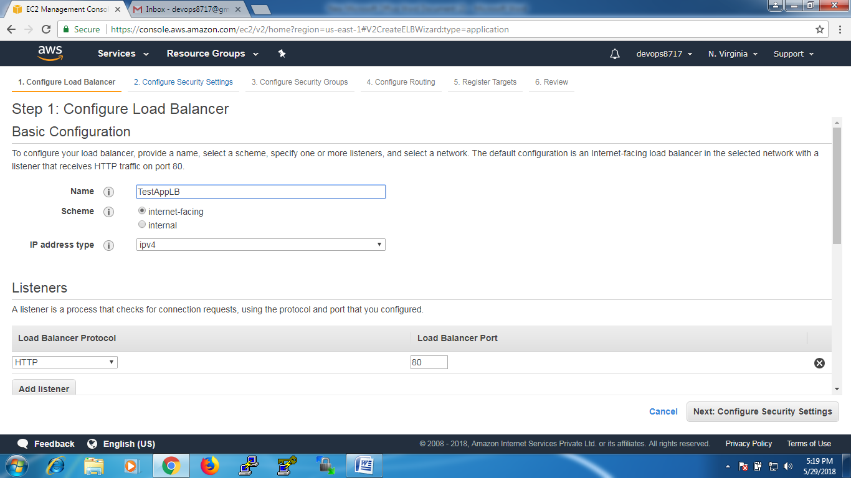

At ‘Availability Zones’ Select our zones i.e ‘us-east-1a’ and ‘us-east-1b’

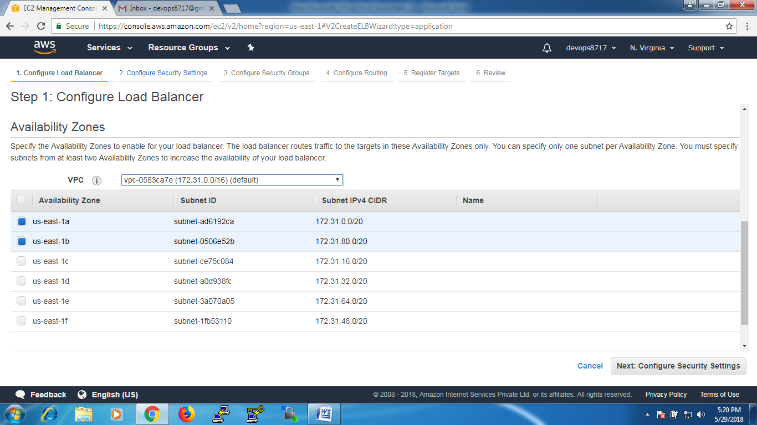

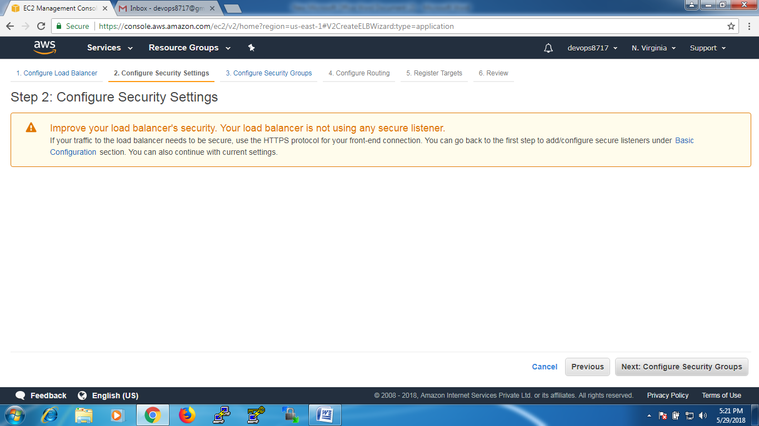

Select our security group

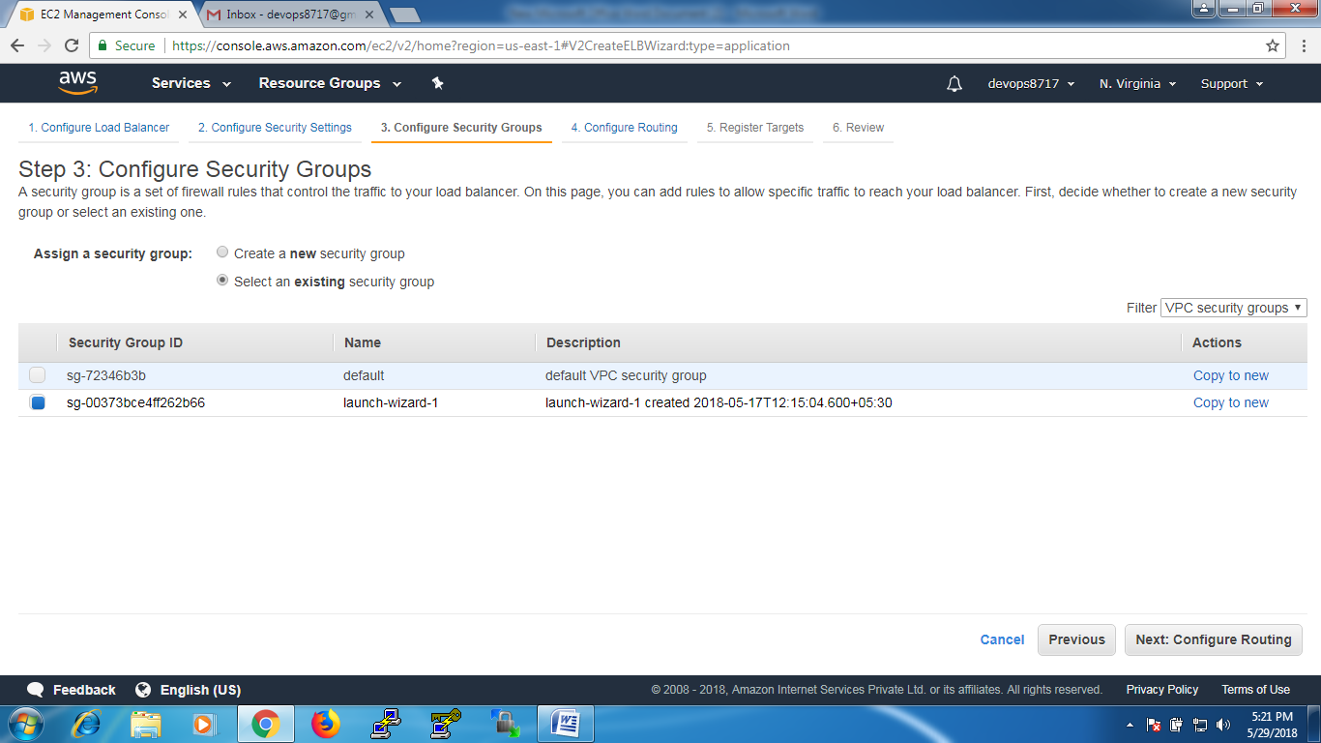

In Target Group, select the ‘picture’ target group as Existing target group

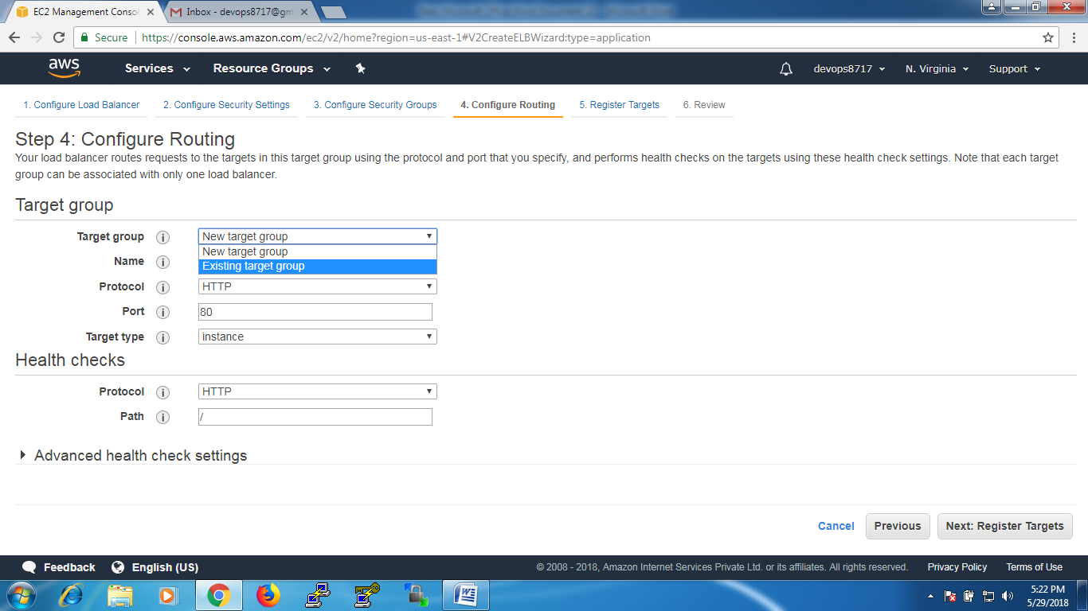

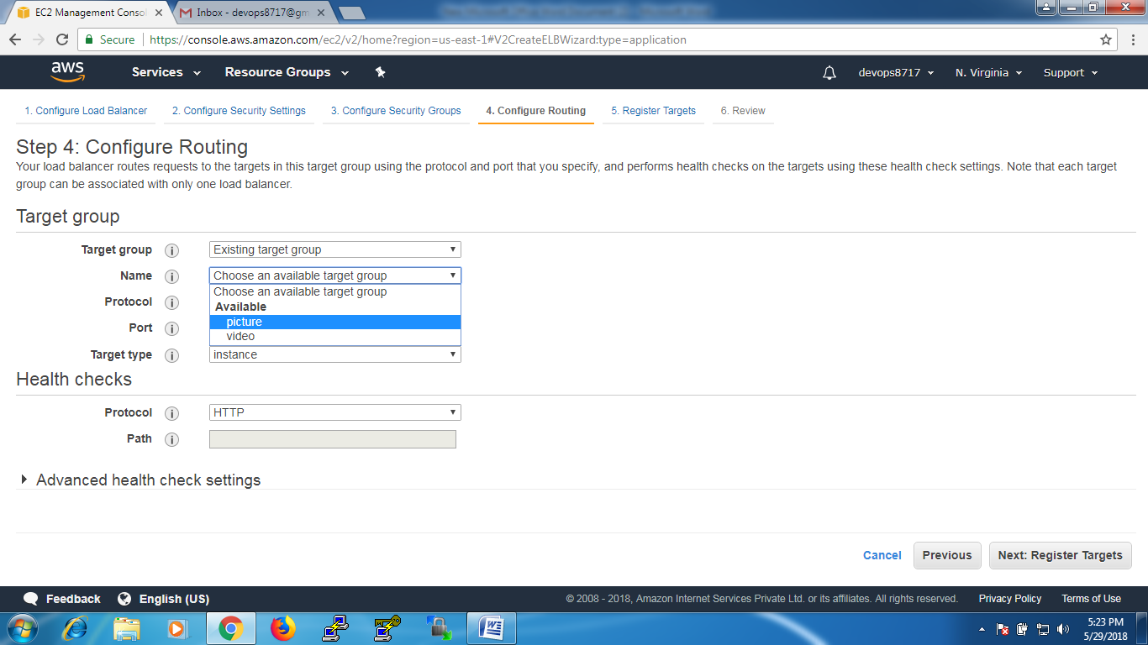

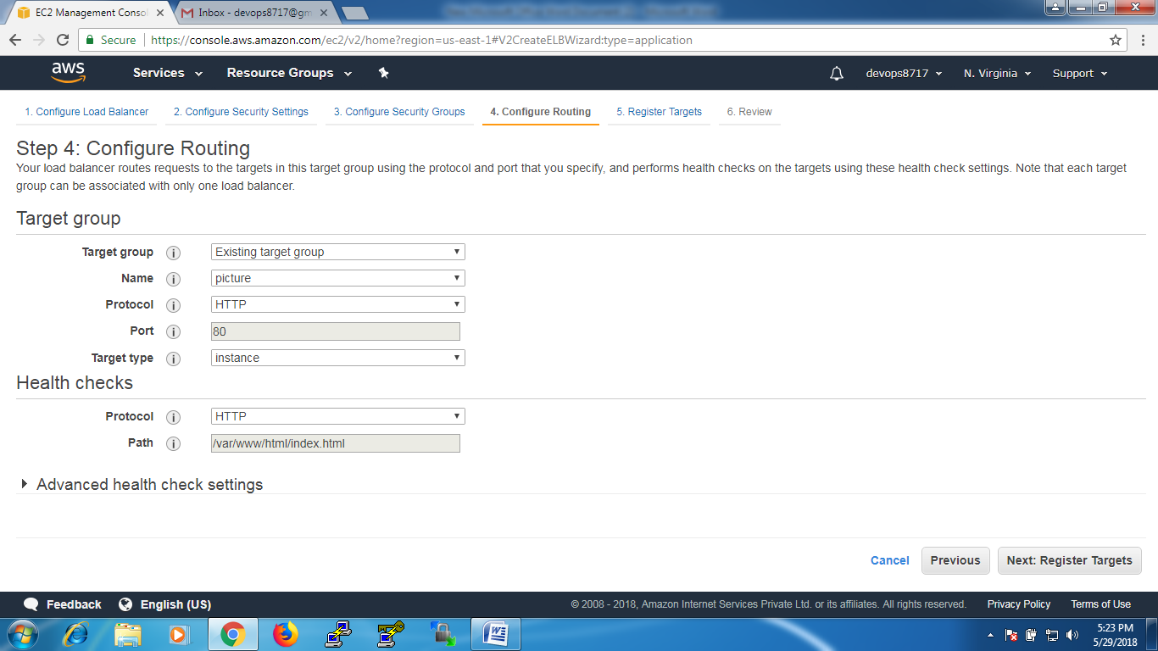

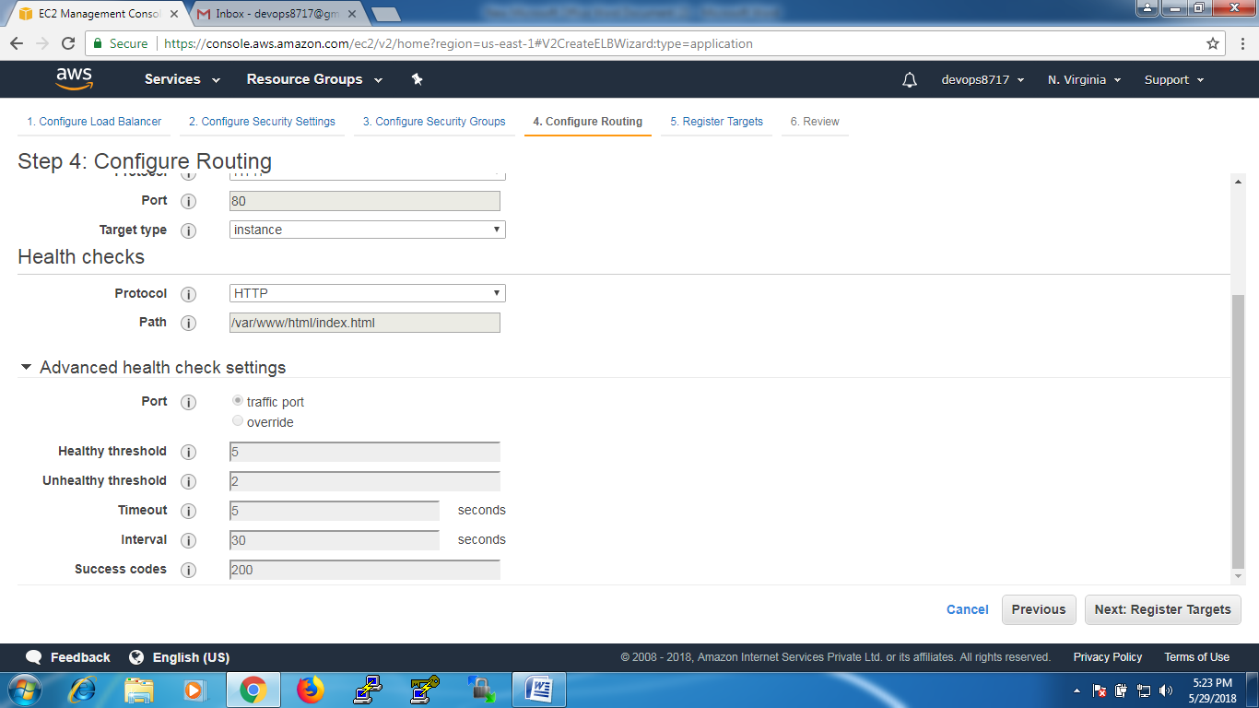

Click register Targets

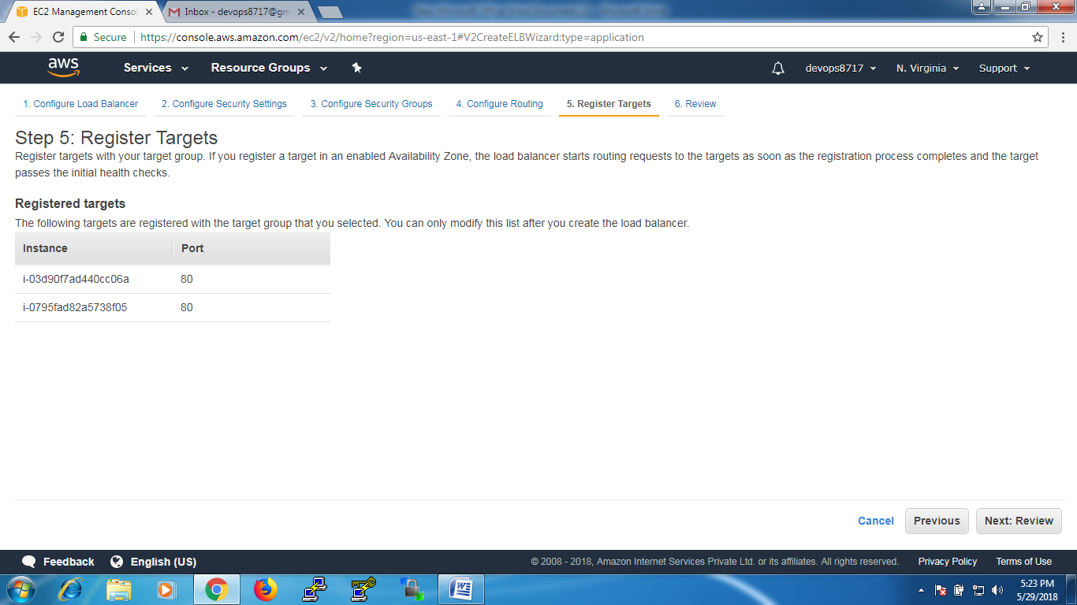

Click on ‘Review’ and then ‘Create’

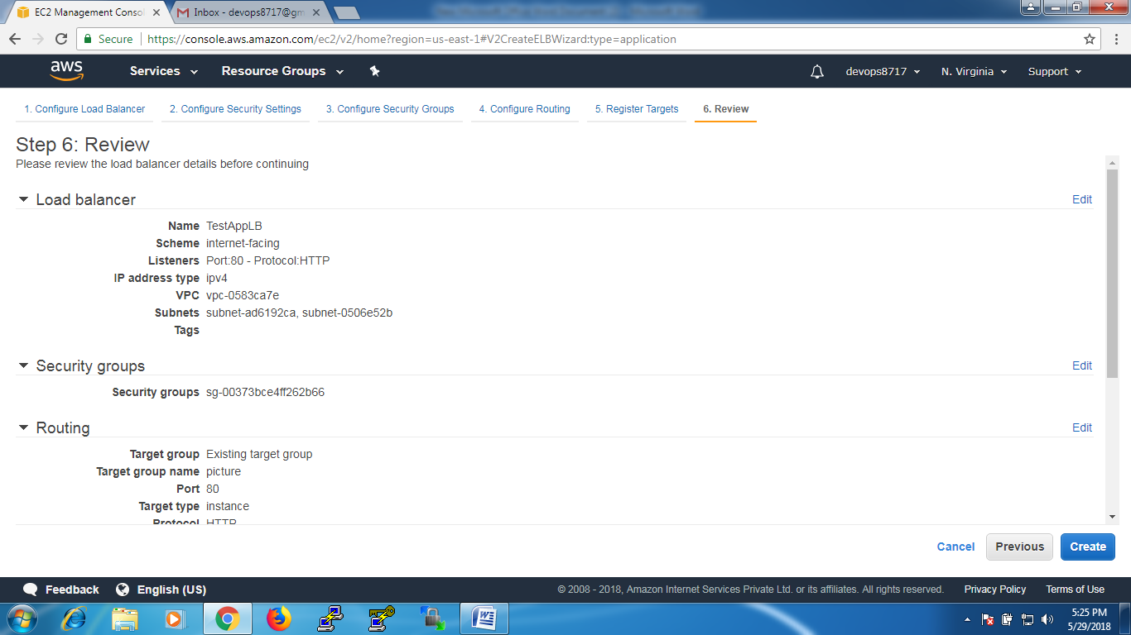

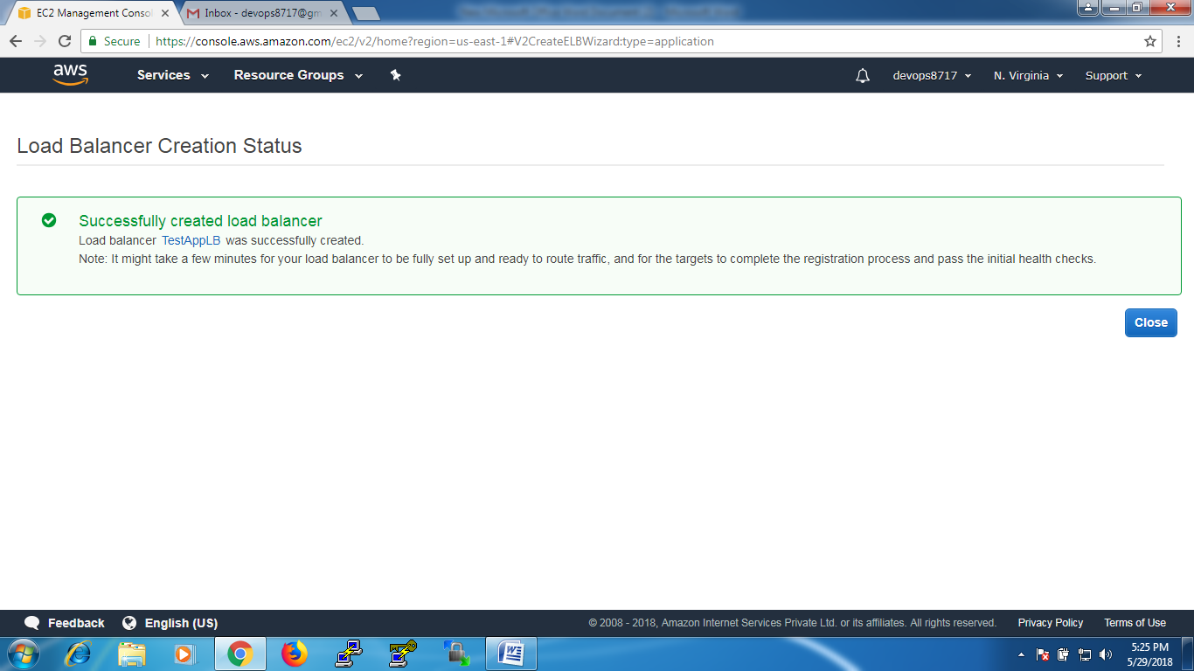

Wait until the status of Load balancer is from ‘provisioning’ to ‘active’

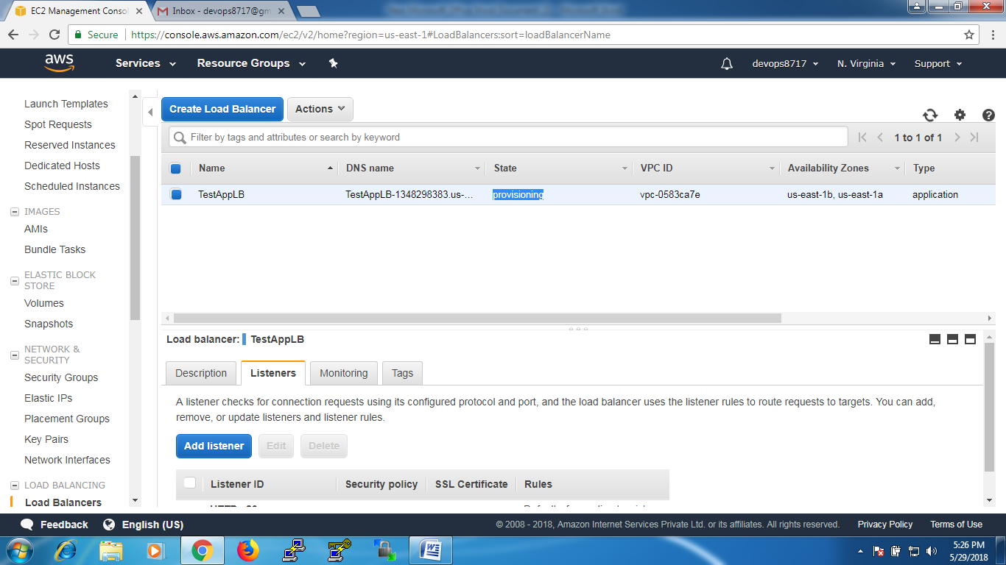

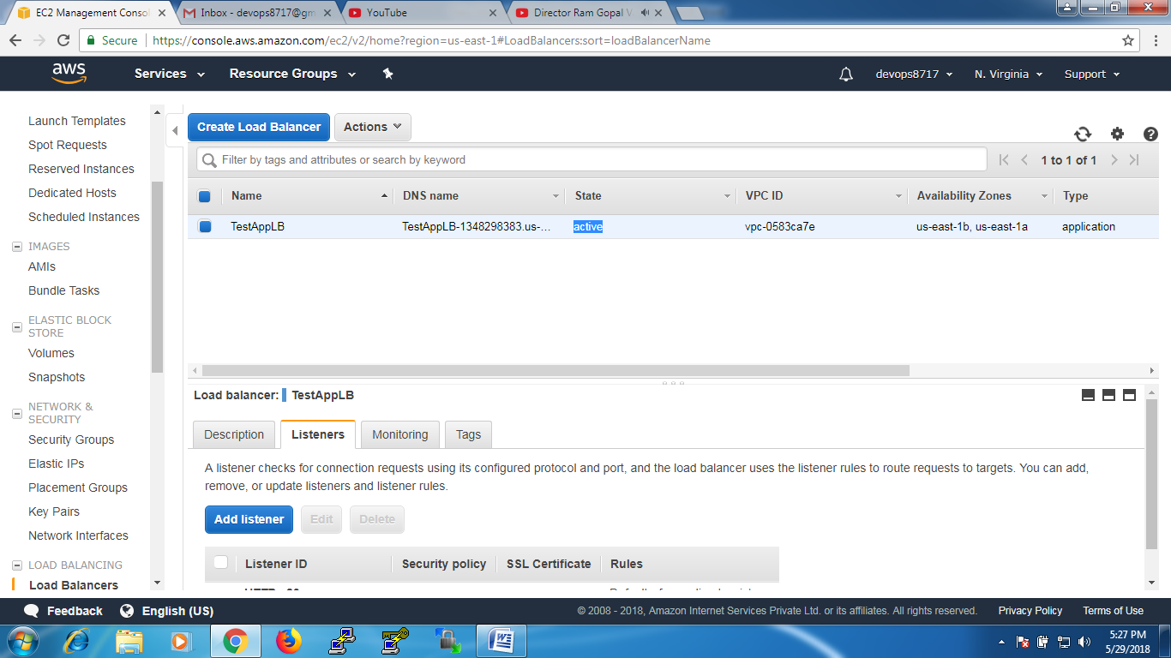

If you see the target group ‘picture’ you will be find that load balancer is attached

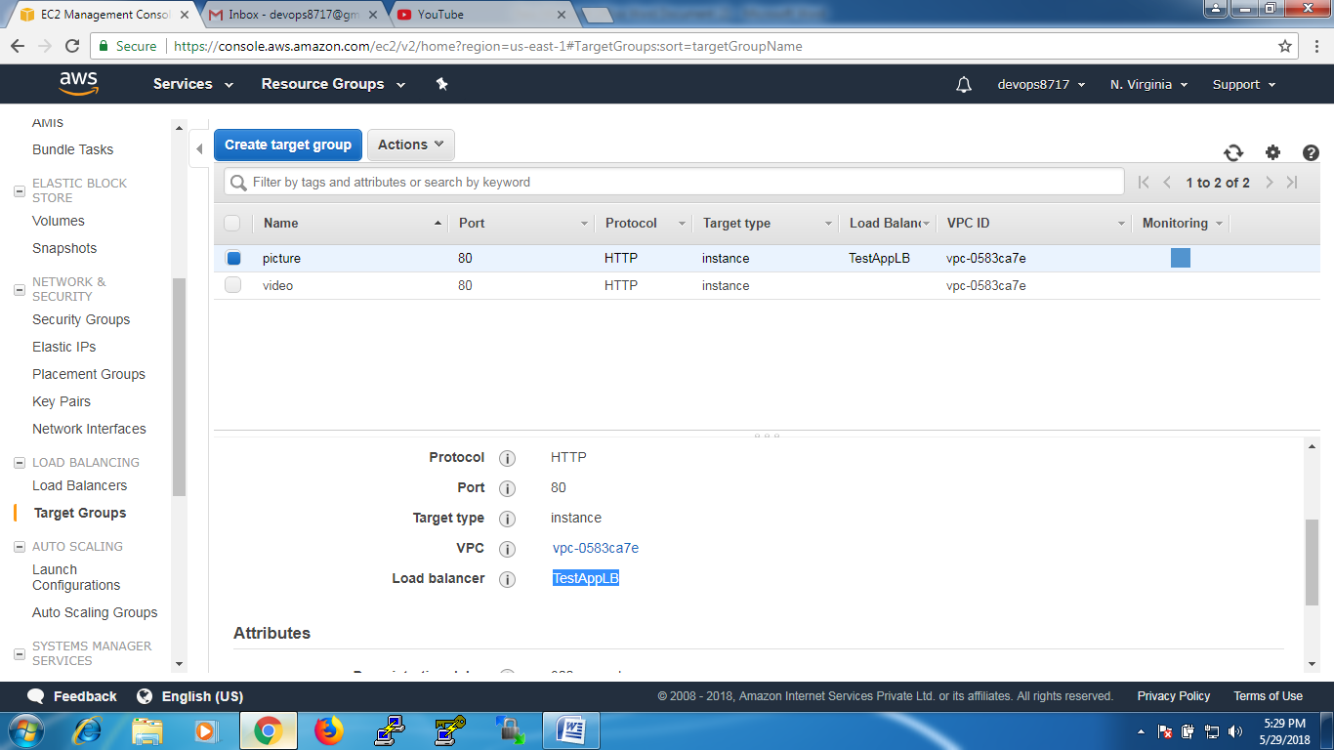

And if you see the target group ‘videos’ it is not, i.e load balancer is not attached to it

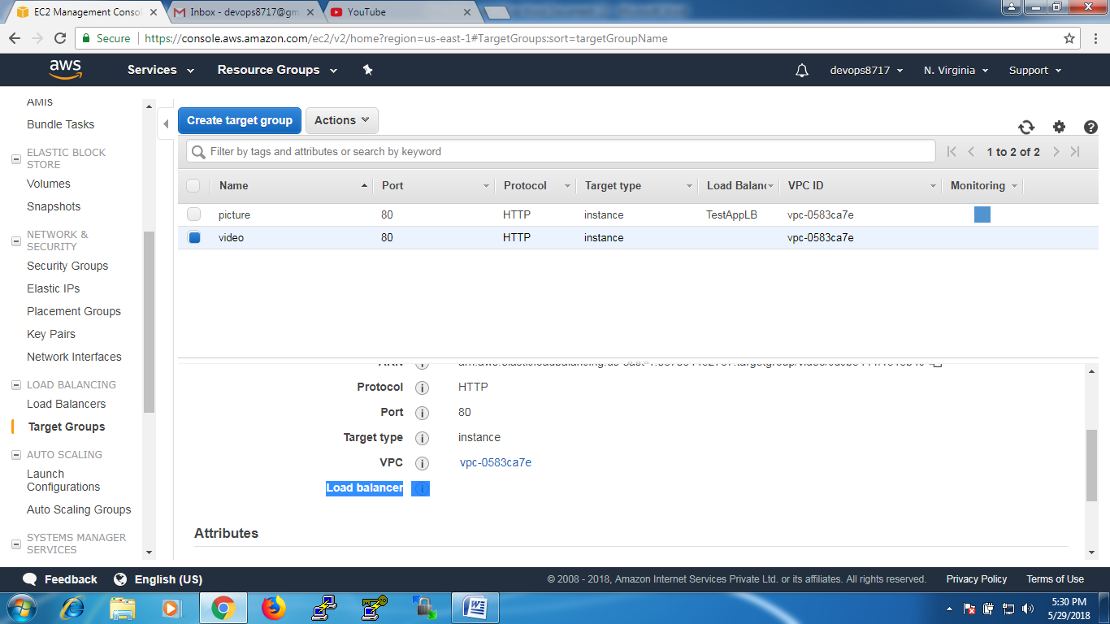

Now go to Load balancer ‘TestAppLB’ – ‘Listeners’ – click on ‘view/edit rules’

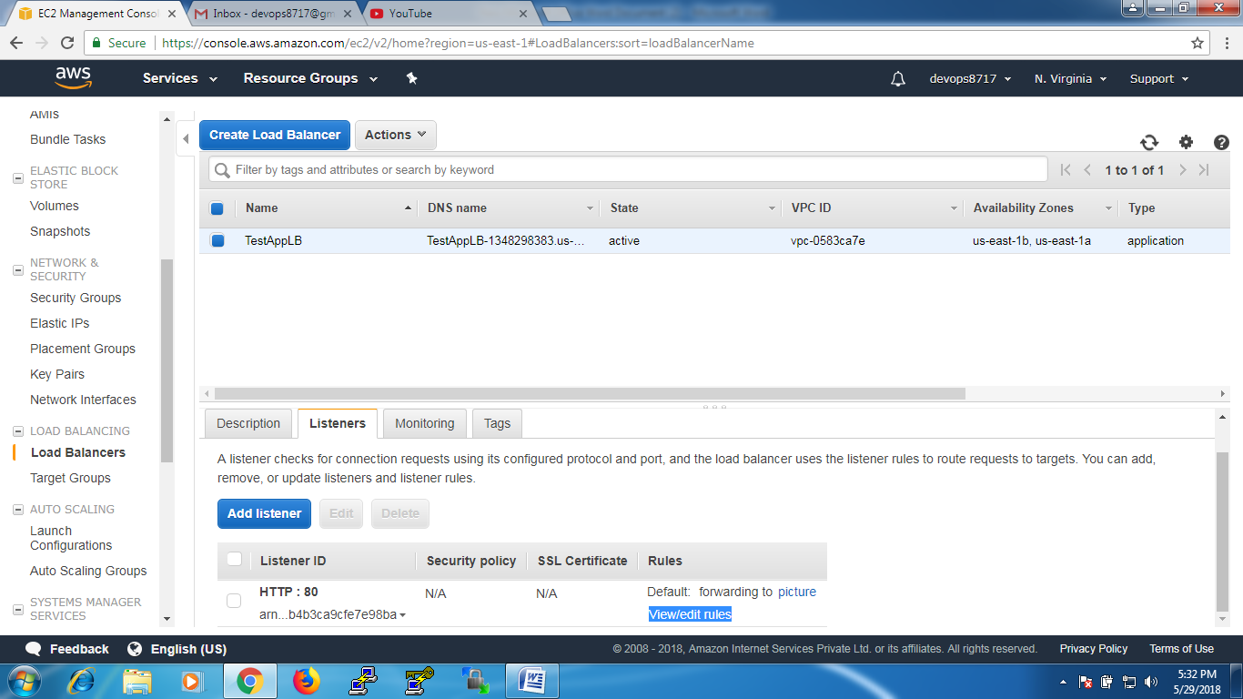 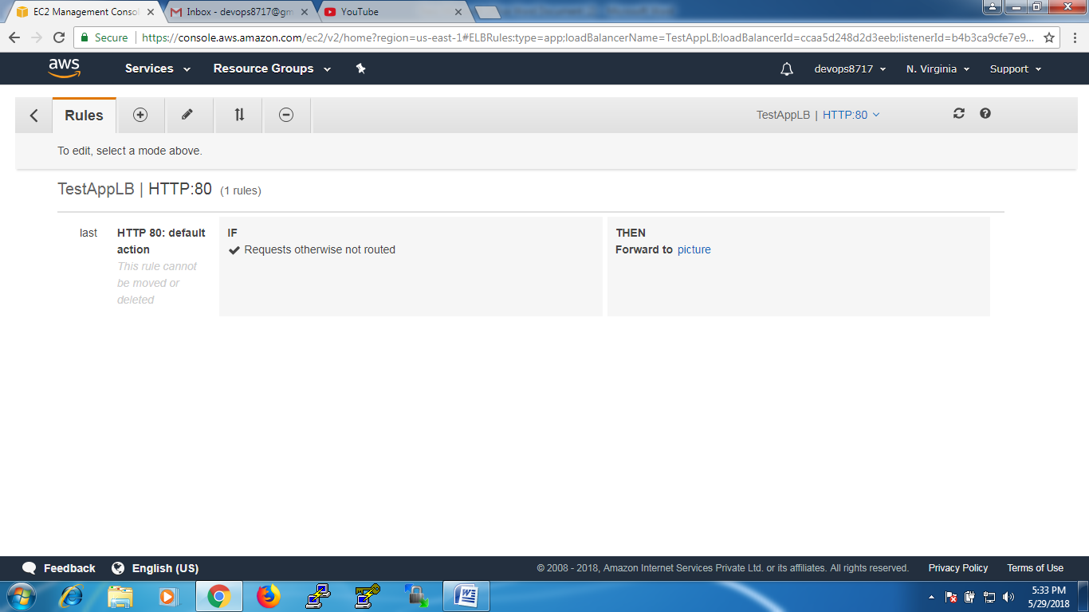

Click on ‘+’ symbol at the top – click on ‘insert rule’

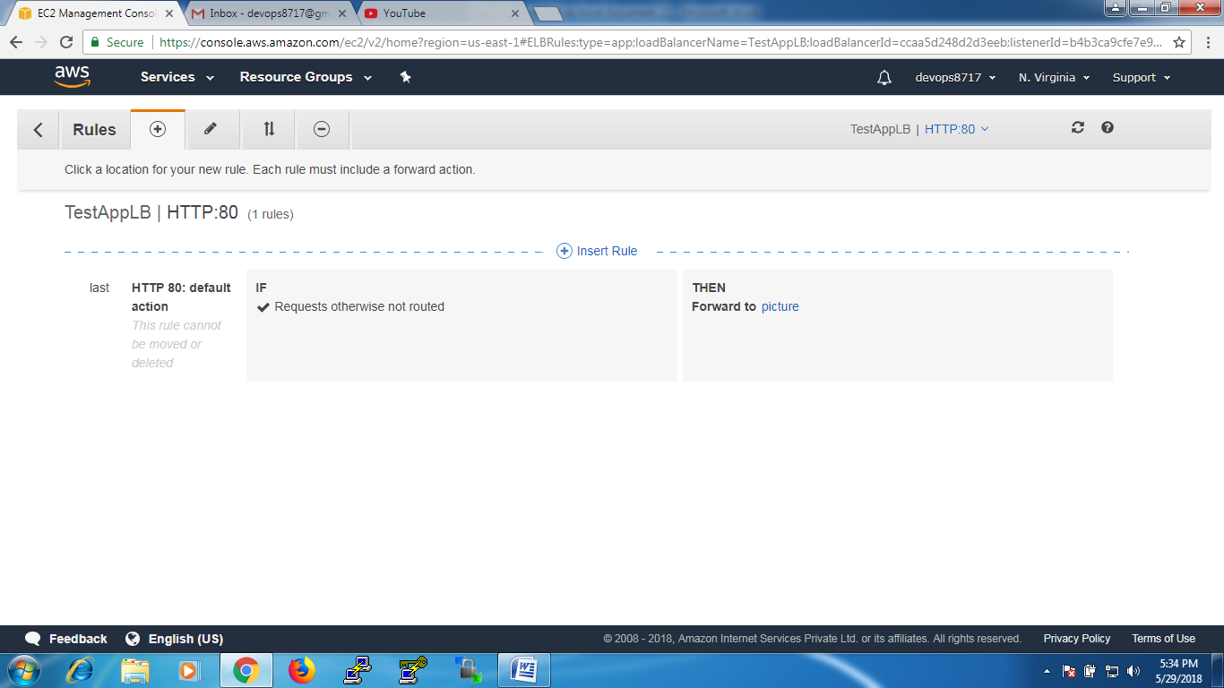

Add action – at “If match all “ select “path is..” type ‘\*picture\*’ i.e target group name.

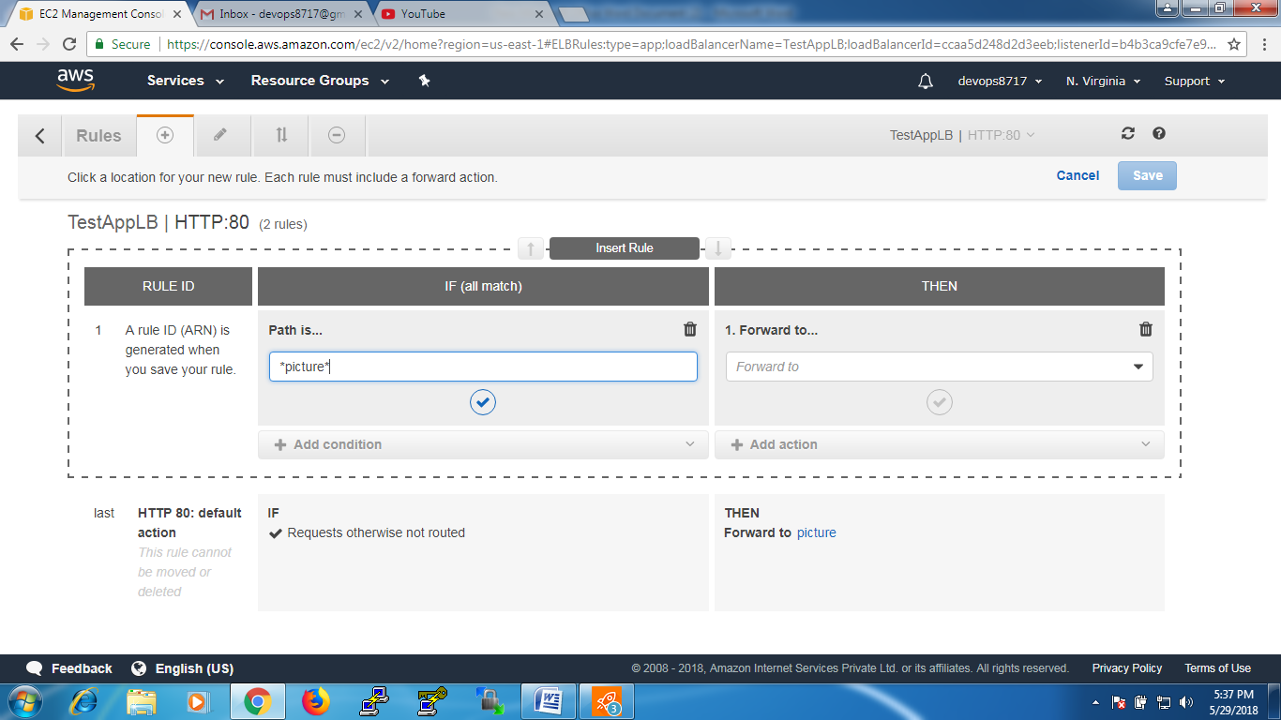

And at the “THEN” part ‘forward to” --- select ‘picture’

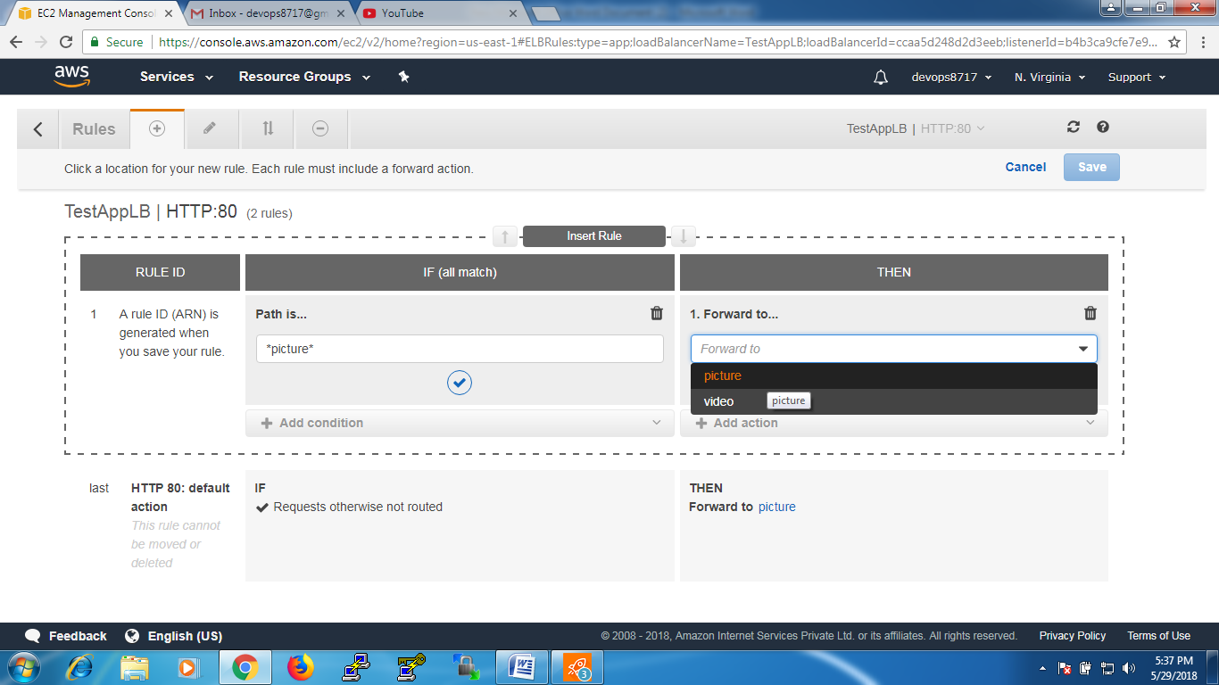

Click on “save”

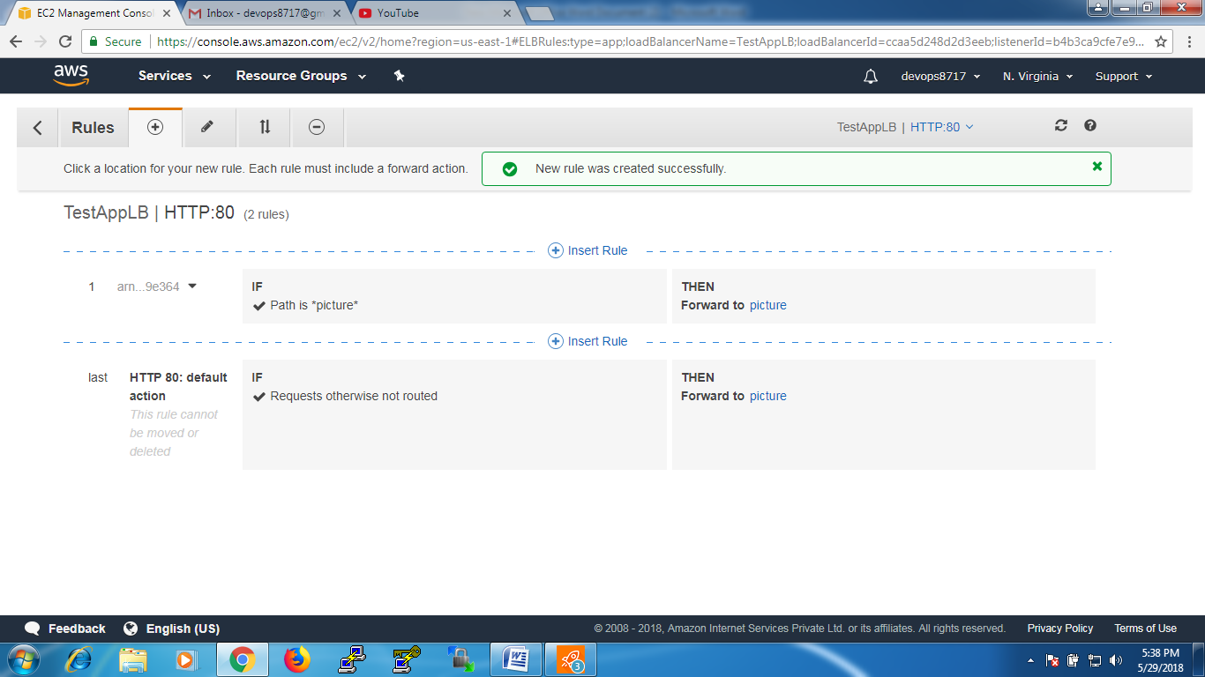

Click on ‘insert rule’ again

Path is --- \*video\* ---- Forward to ‘video’

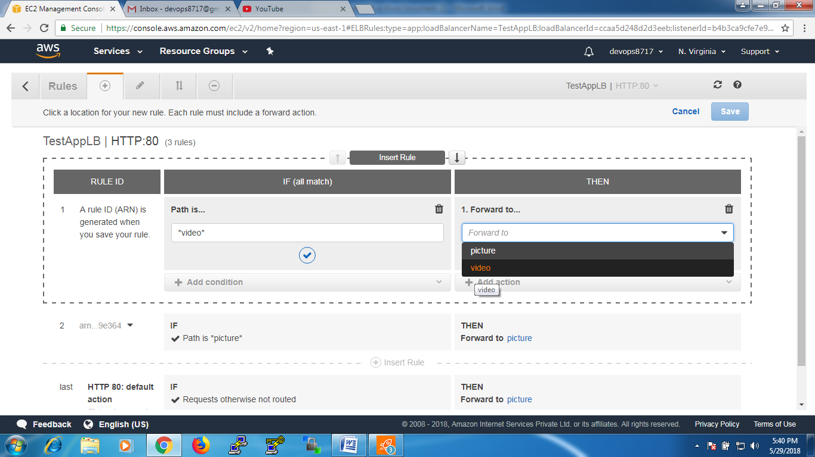

Click on “save”

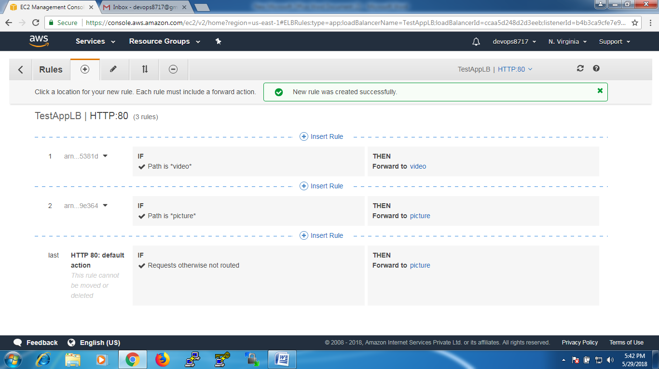

Go to Load balancer ‘TestAppLB’, copy the DNS url

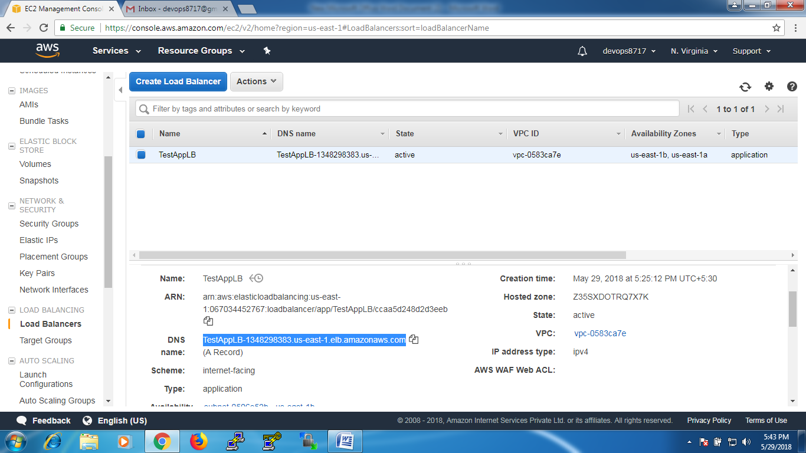

Test that url at browser, will display the result from index.html of webserver1

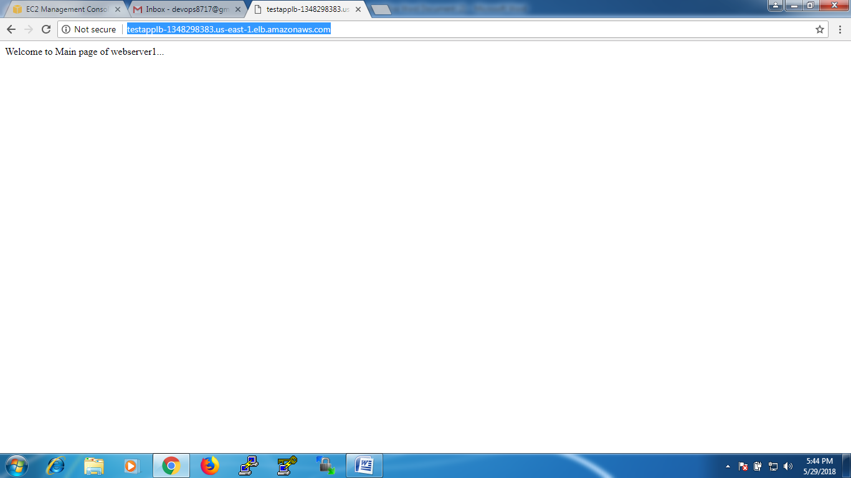

If we continuously hit or refresh the url it will get routed to index.html of webserver2 and display the content in it

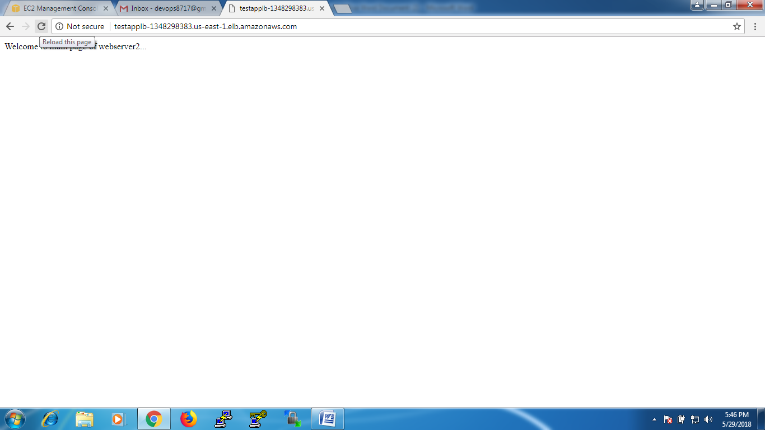

Now test with ‘picture.html’

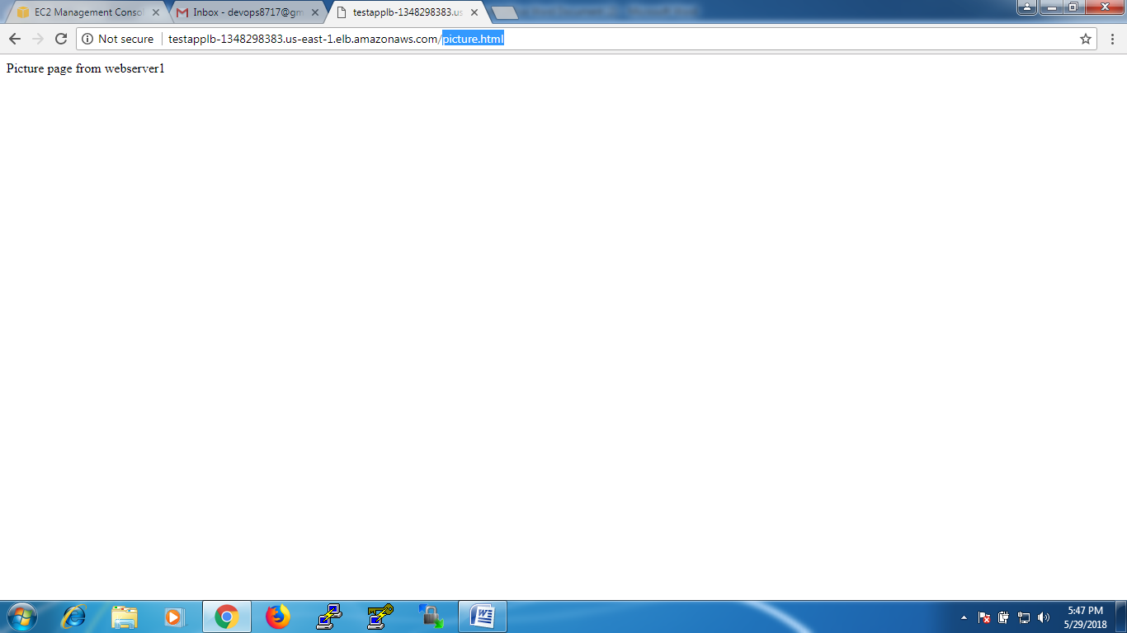

If we continuously ht or refresh the page it will get routed to picture.html page in webserver2

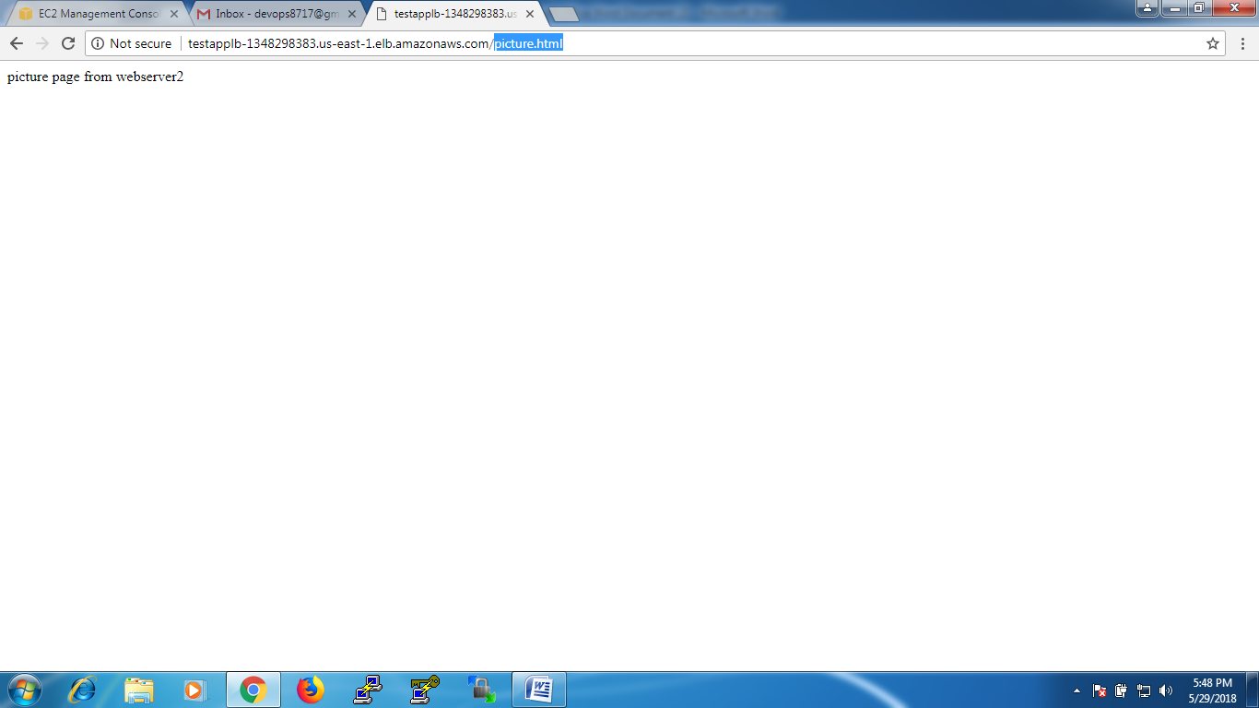

Test the same url with ‘video’, it will get routed to ‘video.html’ in webserver3



If we continuously hit or refresh it will get routed to webserver4 and display the ‘video.html’ content



As we see before for ‘video’ target group we didn’t find ‘Load balancer’ is it … now if we see

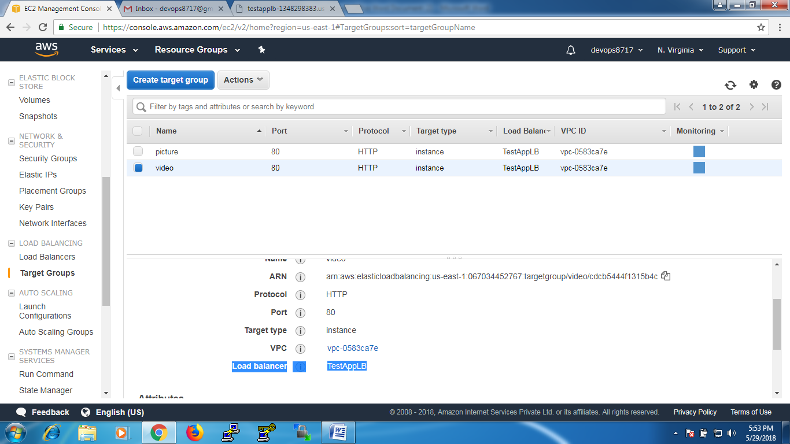

For the content of ‘picture’ load is balancing between webserver1 and webserver2

And the content of ‘video’ the load is balancing between webserver3 and webserver4